Year 6 Autumn 1 - Who’s Taking Control?
English
The Write Stuff
- Fiction (Adventure) – The Firework Maker’s Daughter
- Non-Fiction (Persuasive/Information Speech) – Greta
Guided Reading | Key Texts
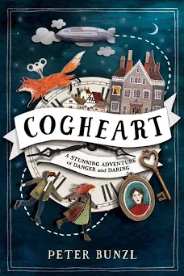 | 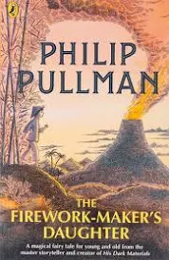 |  | 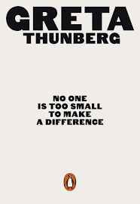
Maths
White Rose Maths – Place Value and Four Operations  - Numbers to 10,000 & 100,000  - Numbers to a million & 10 million  - Compare and order any numbers  - Round numbers to 10,10 & 1000  - Round any number  - Negative numbers  - Add and subtract whole numbers with more than 4 digits  - Inverse operations  - Multi-step addition and subtraction problems  - Add and subtract integers |  | - Multiply up to a 4 digit number by a 2 digit number  - Divide 4 digits by 1 digit  - Divide with remainders  - Short division  - Division using factors  - Long division  - Factors/Common factors  - Common multiples  - Primes to 100  - Squares and cubes  - Order of operations
Science
Switched On Science – Electrical Circuits
- Use recognised symbols to represent a simple circuit in a diagram.
- Compare the reasons for variations in how components function.
- Associate the brightness of a lamp and volume of a buzzer with the number of voltage of cells used in the circuit.
- Research information on renewable energy.
Hands on Science: Make a Buzzer Game
Geography/History
Voyagers Geography - Are we damaging our world?  - Describe key aspects of human geography: settlements, land use, trade links, natural resources.  - Use maps, atlases, globes and digital mapping to locate countries and describe features.  - Use the eight points of a compass, symbols and keys to build knowledge of the UK and the wider world.  - Use fieldwork to observe, measure, record and present human and physical features in the local area. |  | Key Questions:  - Are we damaging our world?  - What are minerals and do we have an endless supply?  - Where does our energy come from?  - Why should we protect our oceans?  - How can we protect our planet in school?
MFL – French
Language Angels – Clothes
- Recognise and recall from memory some items of clothing.
- Explore the verb porter (to wear).
- Describe what you or somebody else is wearing.
- Use of the possessive adjective ‘my’.
- Describe clothes by colour.
Computing
LEGO Mindstorms - Programming
- Apply the four programming constructs: sequence, repetition, selection, variables.
- Build, test and debug in a programming environment.
- Transfer programme to individual Lego Mindstorm robots.
- Evaluate the performance of the programme and suggest improvements.
RE
Hinduism
- Evaluate the benefits of worship in the home or at the mandir for a Hindu and offer explanations for these.
- Explain similarities and differences between Hindu and Christian understandings of God.
- Express clear views about Hindu beliefs and express their own thoughts or beliefs.
PSHE
PSHE Association -
- Families and friendships – different types of relationship; positive and healthy relationships; showing love and commitment; marriage and civil partnerships.
- Media literacy and Digital resilience – Online safety, the risks of social media and rules and laws related to sharing things online.
PE
- Hockey
- Tag Rugby
Art/DT
Silhouettes of Parliament – Monet
- Mix and match colours to create atmosphere and light effects
- Be able to identify primary, secondary, complementary, and contrasting colours
- Work with complementary colours
- Develop a painting from a drawing
- Carry out preliminary work – trying out different media and materials, mixing appropriate colours
- Create imaginative work from a variety of sources (observational drawing, themes, poetry, music)
Music
Happy – Charanga
- To sing in unison and to sing backing vocals.
- To demonstrate a good singing posture.
- To follow a leader when singing.
- To experience rapping and solo singing.
- To listen to each other and be aware of how you fit into the group.
- To sing with awareness of being ‘in tune’
Resilience, Respect, Aspiration and Trust
During this unit the children show resilience and work as a team to build and programme their own Lego Mindstorms robots. As part of working a team, the children must respect each other’s opinions and trust each other to be successful. The children aspire to make a difference by writing to their local MP, calling for action on a matter that is important to them such as: Road Safety and Climate Change.

Year 6 Autumn 2 – Bombs, Battles and Bravery
English
The Write Stuff
- Recount – Letters From The Lighthouse
- Fiction – Narrative – Rose Blanche
Guided Reading | Key Texts
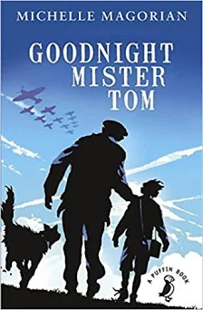 | 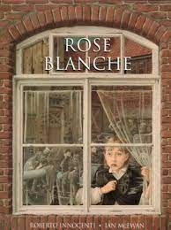 |  | 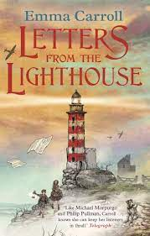
Maths
White Rose Maths – Fractions / Geometry - Position and Direction  - Equivalent fractions  - Simplify fractions  - Improper fractions to mixed numbers  - Mixed numbers to improper fractions  - Fractions on a number line  - Compare and order  - Add and subtract fractions  - Add mixed numbers  - Add fractions |  | - Subtract mixed numbers  - Subtract fractions  - Mixed addition and subtraction  - Multiply and divide fractions by integers  - Multiply and divide fractions by fractions  - Four rules with fractions  - Fractions of an amount  - The first quadrant  - Four quadrants  - Translations  - Reflections
Science
Switched On Science – Light
- Recognise that light appears to travel in straight lines.
- Use the idea that light travels in straight lines to explain why shadows have the same shape as the objects that cast them.
- Use the idea that light travels in straight lines to explain that objects are seen because they give out or reflect light into the eye.
- Recognise that light appears to travel in straight lines.
Hands on Science: Create a lava lamp
Geography/History
History - Key Stage History – World War II  - Say when the war started;  - Discuss some of the countries and key individuals involved.  - Recall some details about key events.  - Describe what evacuation and rationing were, explain how they worked and how different people were affected.  - Describe some of the job’s women did during the war.  - Describe what the Holocaust was and who suffered as a result. |  | - Why did Britain have to go to war in 1939? KQ1  - Why was it necessary for children to be evacuated? Introductory task KQ2  How was Britain able to stand firm against the German threat? KQ3  Why did Germany lose the Battle of Britain?  Britain at war. The Home Front KQ5  What was VE day really like? Advising the film producer KQ6
MFL – French
Language Angels - WW2 - Progressive Language Unit
- Group and order words to decode unknown language.
- Understand the key facts of history from WW2 when described in French.
- Say and write in French the key countries and languages involved in WW2.
- Write a letter in French home explaining what life is like as an evacuee living in the countryside.

Computing
Teach Computing - Computing Systems and Networks - Communication
In this unit, the class will learn about the World Wide Web as a communication tool.
- Learn how we find information on the World Wide Web, through learning how search engines work (including how they select and rank results) and what influences searching, and through comparing different search engines.
- Investigate different methods of communication, before focusing on internet-based communication. Finally, they will evaluate which methods of internet communication to use for particular purposes.
RE
Christmas: What do the Gospels say about the birth of Jesus – and why is it ‘good news’?
- There are four Gospels: Matthew, Mark, Luke and John. People experience and recall the same events in different ways. The events of the nativity are recorded as historical by the writers. The Gospel accounts reveal ‘good news’. There are similarities and differences between the two birth accounts in Matthew and Luke.
- Evaluate reasons why this might be. Compare the events in the two Gospel accounts, suggesting reasons for the differences. Explain what the ‘good news’ in each Gospel is using evidence from the text suggest answers to questions about aspects of the birth of Jesus making reference to both accounts.
PSHE
PSHE Association -
Respecting ourselves and others (Expressing opinions and respecting other points of view, including discussing topical issues
- About the link between values and behaviour and how to be a positive role model; how to discuss issues respectfully; how to listen to and respect other points of view; how to constructively challenge points of view they disagree with; ways to participate effectively in discussions online and manage conflict or disagreements.
PE
- Basketball
- Dance
Art/DT
Frame Structures – Anderson Shelters  Designing  - Carry out research into user needs and existing products, using surveys, interviews, questionnaires, and web-based resources.  - Develop a simple design specification to guide the development of their ideas and products, taking account of constraints including time, resources, and cost.  - Generate, develop and model innovative ideas, through discussion, prototypes and annotated sketches.  Making  - Formulate a clear plan, including a step-by-step list of what needs to be done and lists of resources to be used.  - Competently select from and use appropriate tools to accurately measure, mark out, cut, shape and join construction materials to make frameworks. |  | • Use finishing and decorative techniques suitable for the product they are designing and making.  Evaluating  • Investigate and evaluate a range of existing frame structures.  • Critically evaluate their products against their design specification, intended user and purpose, identifying strengths and areas for development, and carrying out appropriate tests.  • Research key events and individuals relevant to frame structures.  Technical knowledge and understanding  • Understand how to strengthen, stiffen, and reinforce 3-D frameworks.  • Know and use technical vocabulary relevant to the project.
Music
Jazz – Charanga
Improvise using instruments in the context of a song to be performed. Use the improvisation tracks provided

Resilience, Respect, Aspiration and Trust
During this unit the children will learn about the resilience and aspiration that the soldiers showed during the War. In PSHE they will learn about respecting others opinions. The children will also learn about trust and aspiration through the Rose Blanche English unit.

Year 6 Spring 1 – Magnificent Mountains
English
The Write Stuff
- Non-Fiction – Non-Chronological report - Everest
- Fiction – Narrative – Kensuke’s Kingdom
- Poetry – Hope-lo-Docus
Guided Reading | Key Texts
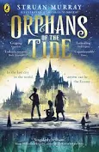 | 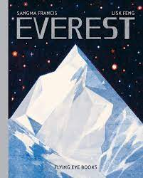 |  | 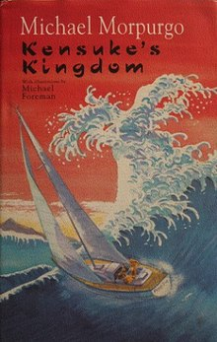
Maths
White Rose – Decimals / Percentages /Algebra  - Decimals up to 2 decimal places  - Understand thousandths Three decimal places  - Multiply by 10, 100 and 1,000  - Divide by 10, 100 and 1,000  - Multiply decimals by integers  - Divide decimals by integers  - Division to solve problems  - Decimals as fractions  - Fractions to decimals  - Understand percentages  - Fractions to percentages |  | - Equivalent FDP Order  - FDP Percentage of an amount  - Percentages – missing values  - Find a rule – two step  - Forming expressions  - Substitution Formulae  - Forming equations  - Solve simple one-step equations  - Solve two-step equations  - Find pairs of values  - Enumerate possibilities
Science
Switched On Science – Evolution and Inheritance
- Recognise that living things produce offspring of the same kind, but normally offspring vary and are not identical to their parents.
- Identify how animals are adapted to suit their environment in different ways and that adaptation may lead to evolution.
- Recognise that living things have changed over time and that fossils provide information about living things that inhabited the Earth millions of years ago.
Hands on Science: Make an electromagnet
Geography/History
Geography - Where should we go on holiday? (Mountains/Alps)  - Use maps to focus on countries, cities and regions in Europe  - Be taught to understand a region of another European country  - Be taught to understand some of the physical and human processes that shape a region  - Extend their knowledge and understanding beyond the local area to include Europe. This will include the location and characteristics of a range of the world’s most significant human and physical features. |  | Key Questions  - Where are the Alps?  - How were the Alps formed?  - How are homes adapted to suit the Alpine climate?  - What are the main industries in the Alps?  - How have glaciers and avalanches changed the landscape?  - What should tourists know about the Alps?
MFL – French
Language Angels French: School - Progressive Language Unit
- Name the subjects we study in school in French with the correct definite article/determiner.
- Extend sentences by giving an opinion on the various school subjects and extend even further by giving a justification for that subject.
- Start to tell the time by learning how to say time by the hour.
- Explore the irregular, high frequency verb aller (to go) in full.
Computing
Teach Computing - Data and Information – Spreadsheets
- Organising data into columns and rows to create their own data set.
- Taught the importance of formatting data to support calculations.
- Introduced to formulas and begin to understand how these can be used to produce calculated data.
- Taught how to apply formulas which include a range of cells and apply formulas to multiple cells by duplicating them.
- Use spreadsheets to plan an event and answer questions.
- Create graphs and charts and evaluate their results in comparison to questions asked.
RE
What is Wisdom?
- Recognise that ‘knowledge’ and ‘wisdom’ are not the same thing. Understand that wisdom is a set of values and experiences which guide people in their lives.
- Explain how wise sayings from important books and leaders can help people live their lives e.g. in Buddhism, Islam, Humanism.
PSHE
PSHE Association - Belonging to a community (Valuing diversity; challenging discrimination and stereotypes)
- What prejudice means; to differentiate between prejudice and discrimination how to recognise acts of discrimination; strategies to safely respond to and challenge discrimination; how to recognise stereotypes in different contexts and the influence they have on attitudes and understanding of different groups; how stereotypes are perpetuated and how to challenge this.

PE
- Gymnastics
- Badminton
Art/DT
Art – Drawing – Mountain Landscapes  - Work from a variety of sources including observation, photographs and digital images  - Work in a sustained and independent way to create a detailed drawing  - Develop close observation skills  - Use sketchbooks to collect and develop ideas  - Identify artists who have worked in a similar way to their own work |  | - Use dry & wet media (ink) to make different marks, lines, patterns, textures and shapes  - Explore colour mixing and blending techniques with coloured pencils  - Use different techniques for different purposes within their own work (shading, hatching)  - Start to develop their own style using tonal contrast and mixed media  - use perspective in their work and an awareness of composition, scale and proportion
Music
A new year carol - Charanga
- Play a musical instrument with the correct technique within the context of the Unit song.
- Select and learn an instrumental part that matches their musical challenge, using one of the differentiated parts – a one-note, simple or medium part or the melody of the song from memory or using notation.
- To rehearse and perform their part within the context of the Unit song.
- To listen to and follow musical instructions from a leader.
- To lead a rehearsal session
Resilience, Respect, Aspiration and Trust
The children will learn about respecting other communities through our PSHE lessons about communities. Resilience, aspiration and trust are evident throughout all three of our key texts for this unit as well as our English lessons.

Year 6 Spring 2 – Who’s The Mummy?
English
The Write Stuff
- Non-Fiction – Biography – Hatshepsut Egypt
- Fiction – Narrative – The Graveyard Book
Guided Reading | Key Texts
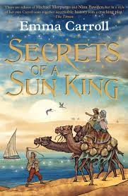 | 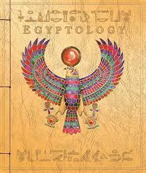 |  | 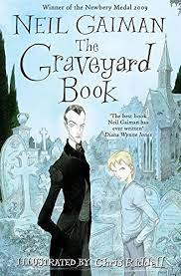
Maths
White Rose – Converting Units/ Area, Perimeter and Volume/ Ratio  - Metric measures  - Convert metric measures  - Calculate with metric measures  - Miles and kilometres  - Imperial measures  - Shapes – same area  - Area and perimeter  - Area of a triangle  - Area of parallelogram |  | - What is volume?  - Volume – counting cubes  - Volume of a cuboid  - Using ratio language  - Ratio and fractions  - Introducing the ratio symbol  - Calculating ratio  - Using scale factors  - Calculating scale factors  - Ratio and proportion problems
Science
Switched On Science – Animals including Humans
- Identify and name the main parts of the human circulatory system, and describe the main functions of the heart, blood vessels and blood.
- Recognise the impact of exercise on the way their bodies function.
Hands on Science: Record BPM during a ‘Sports Day’
Geography/History
History – Key Stage History - The Egyptians  - Know where and when the Egyptians lived through looking at maps and artefacts.  - Select information about mummification and Egyptian gods.  - Understand what was important to people during ancient Egyptian times.  - Compare the powers of different Egyptian gods. |  | How can we discover what Ancient Egypt was like over 5,000 years ago? KQ2  The opening of Tutankhamun’s tomb : KQ3 part 1  So who did build the pyramids? KQ3 part 2 Did the Prince of Egypt film get it right?  Using evidence of Life in Ancient Egypt KS2: KQ4  Embalming the dead in Ancient Egypt : KQ5  Ancient Egyptian after-life lesson KS2: KQ5 part 2  What did Ancient Egypt have in common with other civilizations at the time? KS2: KQ6
MFL – French
Language Angels French: French: Regular Verbs - Progressive Language Unit
- Understand better what personal/subject pronouns are.
- Understand better the concept of verb stems and endings.
- Conjugate easily and with clear understanding regular -er verbs like JOUER.
- Conjugate easily and with clear understanding regular -ir verbs like FINIR.
- Conjugate easily and with clear understanding regular -re verbs like VENDRE.
Computing
Teach Computing - Creating Media – 3D Modelling
- Develop their knowledge and understanding of using a computer to produce 3D models.
- Learners will initially familiarise themselves with working in a 3D space, including combining 3D objects to make a house and examining the differences between working digitally with 2D and 3D graphics.
- Making accurate 3D models of physical objects, such as a pencil holder, which include using 3D objects as placeholders.
- Examine the need to group 3D objects, then go on to plan, develop, and evaluate their own 3D model of a photo frame.
RE
Adam, Eve, Christmas, Easter: what are the connections?
- Christians believe that: there are links between events in Genesis and the events of Easter and Christmas, ancient prophecies in the Old Testament foretell the birth and death of Jesus, ancient prophecies in the Old Testament show that God still loved His people even when they disobeyed Him, Jesus did the job that it was prophesied he would do.
- Explain the connections between Adam, Eve, Christmas and Easter, using evidence from the Bible / their research. Suggest answers to the questions about sin, the person of Jesus and what Christians believe about the purpose of his coming.
PSHE
PSHE Association - Money and Work (Influences and attitudes to money; money and financial risks
- About the role that money plays in people’s lives, attitudes towards it and what influences decisions about money;
- About value for money and how to judge if something is value for money;
- How companies encourage customers to buy things and why it is important to be a critical consumer;
- How having or not having money can impact on a person’s emotions, health and wellbeing; about common risks associated with money, including debt, fraud and gambling; how money can be gained or lost e.g. stolen, through scams or gambling.
PE
- Tennis
- Fitness
Art/DT
DT - Pulleys and Gears  Designing  • Generate innovative ideas by carrying out research using surveys, interviews, questionnaires and web-based resources.  • Develop a simple design specification to guide their thinking.  • Develop and communicate ideas through discussion, annotated drawings, exploded drawings and drawings from different views.  Making  • Produce detailed lists of tools, equipment and materials. Formulate step-by-step plans and, if appropriate, allocate tasks within a team.  • Select from and use a range of tools and equipment to make products that that are accurately assembled and well finished. Work within the constraints of time, resources and cost.  • Know and use technical vocabulary relevant to the project. |  | Evaluating  • Compare the final product to the original design specification.  • Test products with intended user and critically evaluate the quality of the design, manufacture, functionality and fitness for purpose.  • Consider the views of others to improve their work.  • Investigate famous manufacturing and engineering companies relevant to the project.  Technical knowledge and understanding  • Understand that mechanical and electrical systems have an input, process and an output.  • Understand how gears and pulleys can be used to speed up, slow down or change the direction of movement.
Music
You’ve got a friend - Charanga
- Create simple melodies using up to five different notes and simple rhythms that work musically with the style of the Unit song.
- Explain the keynote or home note and the structure of the melody.
- Listen to and reflect upon the developing composition and make musical decisions about how the melody connects with the song.
- Record the composition in any way appropriate that recognises the connection between sound and symbol (e.g. graphic/pictorial notation).
Resilience, Respect, Aspiration and Trust
Through our PSHE the children will develop aspirations for the future. They will show resilience through problem solving in their DT project and respect each other when working as a team.

Year 6 Summer 1 – Welcome to the Rainforest
English
The Write Stuff
- Non-Fiction – Non-Chronological – The Origin of Species
- Fiction – Narrative – The Explorer
Guided Reading | Key Texts
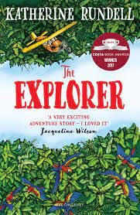 | 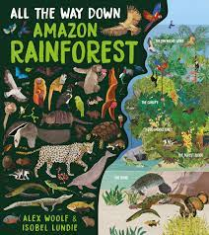 |  | 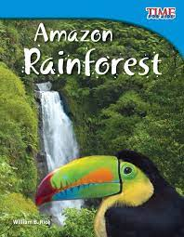
Maths
White Rose Maths – Statistics/Properties of Shape  - Read and interpret line graphs  - Draw line graphs  - Use line graphs to solve problems  - Circles  - Read and interpret pie charts  - Pie charts with percentages  - Draw pie charts  - The mean  - Measure with a protractor  - Draw lines and angles accurately |  | - Introduce angles  - Angles on a straight line  - Angles around a point  - Calculate angles  - Vertically opposite angles  - Angles in a triangle  - Angles in a triangle – missing angles  - Angles in special quadrilaterals  - Angles in regular polygons  - Draw shapes accurately  - Draw nets of 3-D shapes
Science
Switched On Science – Living Things and Their Habitats
- How living things are classified into broad groups.
- Give reasons for classifying animals based on specific characteristics.
- Classify into broad groups according to common observable characteristics and based on similarities and differences – including micro-organisms. & including fungi & Five Kingdoms
Hands on Science: Build a bug hotel
Geography/History
Voyagers Geography - What is it like in the Amazon?  - Extend their knowledge and understanding beyond their local area to include South America  - Develop their use of geographical knowledge, understanding and skills to enhance their locational and place knowledge  - Locate the world's countries using maps, and concentrate on their environmental regions, key physical and human characteristics, countries and major cities  - Understand geographical similarities and differences studied through the study of human and physical geography of a region in South America |  | - Describe and understand key aspects of physical and human geography  - Use maps, atlases, globes and digital/computer mapping to locate countries and describe features  Key questions:  - What is it like in the Amazon?  - Where is the Amazon?  - What would it be like to take a walk through the Amazon rainforest?  - What is Manaus like?  - Do people live in the Amazon rainforest?  - How can people protect the Amazon?  - Why should we protect the Amazon?
MFL – French
Language Angels – French: Weekend - Progressive Language Unit
- Tell the time in French using quarter past, half past and quarter to.
- Say and write in French what we do at the weekend using two or more sentences.
- Integrate conjunctions and opinions into written and spoken work to make more interesting and extended sentences.
Computing
Creating Media – Web Page Creation
- Introduces learners to the creation of websites for a chosen purpose.
- Identify what makes a good web page and use this information to design and evaluate their own website using Google Sites.
- Pay specific attention to copyright and fair use of media, the aesthetics of the site, and navigation paths.
RE
What is the ‘Buddhist way of life’?
- The story of how Prince Siddattha became Buddha. ‘Buddha’ means ‘awakened’ or ‘enlightened one.
- There is no supreme deity in Buddhism. Buddhists follow the teachings of Buddhism to gain enlightenment (Nirvana) which is achieved by meditating. There are Four Noble Truths in Buddhism. Buddhists follow the teachings of the Eightfold Path. There are artefacts that help Buddhists to meditate. Worship and meditation are different.
- Gather, select & organise ideas about Buddhism.
- Consider how the four Noble Truths or the Eightfold Path might affect a Buddhist’s way of life. Connect the key beliefs and teachings of Buddhism with features of the religion (artefacts, symbols, rituals).
- Apply ideas and reflections about issues raised (suffering, enlightenment, meditation) to their own, and Buddhists’.
- Consider whether worship and meditation are different things and why this might be

PSHE
PSHE Association - Physical health and Mental wellbeing
- That mental health is just as important as physical health and that both need looking after;
- To recognise that anyone can be affected by mental ill-health and that difficulties can be resolved with help and support; how negative experiences such as being bullied or feeling lonely can affect mental wellbeing; positive strategies for managing feelings; that there are situations when someone may experience mixed or conflicting feelings; how feelings can often be helpful, whilst recognising that they sometimes need to be overcome;
- Recognise that if someone experiences feelings that are not so good (most or all of the time) – help and support is available
PE
- Athletics
- Orienteering
Art/DT
Sketching - Plants and Rainforest animals – Banksy Style:
- Select & record from first-hand observation, experience & imagination and explore ideas for different purposes
- Question, make thoughtful observations about starting points, select ideas to use in their artwork
- Explore the roles and purposes of artists, craftspeople and designers working in different times and cultures.

Music
Music and Me - Charanga
- To choose what to perform and create a programme.
- To communicate the meaning of the words and clearly articulate them.
- To talk about the venue and how to use it to best effect.
- To record the performance and compare it to a previous performance.
- To discuss and talk musically about it – “What went well?” and “It would have been even better if...?”
Resilience, Respect, Aspiration and Trust
Through our Guided Reading and English units, the children will experience characters showing great resilience and trust in each other to survive in the Rainforest. The children will also develop a respect for the Buddhist way of life.

Year 6 Summer 2 – Lights, Camera, Action
English
The Write Stuff
- Fiction – Narrative - Paperman by Disney
- Fiction – Narrative – The Journey
Guided Reading | Key Texts
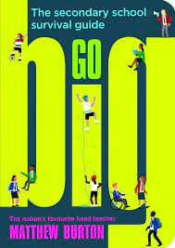 | 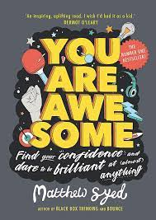 |  | 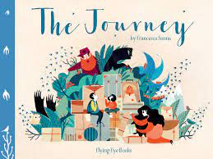
Maths
White Rose Maths – Consolidation  - Place Value  - Four Operations  - Fractions, Decimals and Percentages  - Position and Direction  - Algebra |  | - Converting Units  - Perimeter, Area and Volume  - Ratio  - Statistics  - Properties of Shape
Science
Switched On Science – Scientists and Inventors  - Describe their observations from an enquiry into black holes.  - Classify invertebrates using prompts.  - Explain the role of DNA in inheritance  - Describe the race to discover the structure of DNA. Describe the evidence that Watson and Crick used to prove the structure of DNA. |  | - Answer questions about the effects of penicillin using a scatter graph.  - Explain the importance of the fossils found by Mary Leakey.  - Use recognised symbols to represent computer components.  Hands on Science: Density Experiment using fruit juices – Making Mocktails
Geography/History
MFL – French
Language Angels French: Me in the World - Progressive Language Unit
- Say and spell some of the different countries and the relative capital cities in the French-speaking world and find them on a map.
- Say and write about some key celebrations in the French speaking world and some of the differences in terms of geography and historical sites between Paris and Port-au-Prince.
- Say and write something we do to help the planet.
Computing
Film Making – Documentary about making the school play  - Plan additional elements for film making such as location and props.  - Evaluate whether information is reliable or not. |  | - Speak clearly into the camera when being recorded.  - Frame appropriate filming shot when interviewing.  - Arrange video files to form a complete film.
RE
How can churches help us to understand Christian belief?
- The significant features found in churches of two Christian denominations.
- The meaning of Christian symbols found in churches and the different beliefs these express.
- Communion and baptism are practices for all Christians because Jesus told them to do these things. There are similarities and differences between Christian denominations. Different denominations have features and practices unique to them. gather, select, and organise ideas about communion or baptism across two denominations.
- Comment on the connections between beliefs and practices for different denominations.
- Describe why people choose to express their beliefs in different ways giving examples.

PSHE
PSHE Association – Growing and changing  - To recognise some of the changes as they grow up e.g. increasing independence about what being more independent might be like, including how it may feel about the transition to secondary school and how this may affect their feelings about how relationships may change as they grow up or move to secondary school.  - Practical strategies that can help to manage times of change and transition e.g. practising the bus route to secondary school; identify the links between love, committed relationships and conception what sexual intercourse is, and how it can be one part of an intimate relationship between consenting adults; how pregnancy occurs i.e. when a sperm meets an egg and the fertilised egg settles into the lining of the womb; that pregnancy can be prevented with contraception; about the responsibilities of being a parent or carer and how having a baby changes someone’s life. |  | Relationships Education (CWP 2020)  Lesson 1- Puberty & Reproduction (body changes during puberty in preparation for reproduction)  Lesson 2 – Communication in Relationships (healthy & unhealthy relationships, communication & consent) Lesson 3 – Families, Conception & Pregnancy (consider different ways people start a family, decisions, conception & pregnancy)  Lesson 4 -Online relationships (positive and negative ways of communicating in a relationship, sharing private/personal info online and where to get support)  Keeping Safe  Keeping personal information safe; regulations and choices; drug use and the law; drug use and the media  Secondary School Transition  
PE
- Rounders |  | - Handball
Art/DT
Crumble  Designing  - Develop a design specification for a functional product that responds automatically to changes in the environment.  - Generate, develop and communicate ideas through discussion, annotated sketches and pictorial representations of electrical circuits or circuit diagrams.  Making  - Formulate a step-by-step plan to guide making, listing tools, equipment, materials and components.  - Competently select and accurately assemble materials, and securely connect electrical components to produce a reliable, functional product.  - Create and modify a computer control program to enable their electrical product to respond to changes in the environment. |  | Evaluating  - Continually evaluate and modify the working features of the product to match the initial design specification.  - Test the system to demonstrate its effectiveness for the intended user and purpose.  Technical knowledge and understanding  - Understand and use electrical systems in their products.  - Understand the use of computer control systems in products.  - Apply their understanding of computing to program, monitor and control their products.  - Know and use technical vocabulary relevant to the project.
Music
Reflect, Rewind and Replay - Charanga
- Use musical words when talking about the songs.
- To talk about the musical dimensions working together in the Unit songs.
- Talk about the music and how it makes you feel, using musical language to describe the music.

Resilience, Respect, Aspiration and Trust
The children spend this unit celebrating their time at Shawfield and preparing themselves for their transition to secondary school. The children will prepare their leavers assembly and take part in the end of year school production.

