Year 5 Autumn 1 – Out of this World
English
The Write Stuff
- Fiction - Narrative - One Small Step
- Non-fiction - Diary – Mars Transmission
Guided Reading | Key Texts
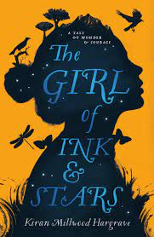 |  |  | 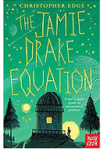
Maths
White Rose Maths – Place Value/Addition & Subtraction/Statistics  - 1000s, 100s, 10s &1s  - Numbers to 10,000  - Rounding to the nearest 10  - Rounding to the nearest 100  - Rounding to 10, 100 and 1,000  - Numbers to 100,000  - Compare and order numbers to 100,000  - Round numbers within 100,000  - Negative numbers  - Roman numerals  - Add two 4-digit numbers - one exchange  - Add two 4-digit numbers - more than one exchange  - Add whole numbers with more than 4 digits (column method) |  | - Subtract two 4-digit numbers - one exchange  - Subtract two 4-digit numbers - more than one exchange  - Subtract whole numbers with more than 4 digits (column method)  - Round to estimate and approximate  - Inverse operations (addition and subtraction)  - Multi-step addition and subtraction problems  - Interpret charts  - Comparison, sum and difference  - Introduce line graphs  - Read and interpret line graphs  - Draw line graphs  - Use line graphs to solve problems  - Read and interpret tables  - Two-way tables  - Timetables
Science
Earth and Space
- describe the movement of the Earth, and other planets, relative to the Sun in the solar system
- describe the movement of the Moon relative to the Earth
- describe the Sun, Earth and Moon as approximately spherical bodies
- use the idea of the Earth’s rotation to explain day and night and the apparent movement of the sun across the sky
Geography/History
Voyagers Geography – How will our world look like in the future?  - Describe and understand key aspects of: physical geography, including: climate zones, biomes and vegetation belts, rivers, mountains, volcanoes and earthquakes, and the water cycle − human geography, including: types of settlement and land use, economic activity, and the distribution of natural resources including energy, food, minerals and water  - Learn geographical skills and fieldwork: use maps and  symbols to build their knowledge of the United  Kingdom  - Use fieldwork to observe, measure, record and present features in the local area using a range of methods, including sketch maps, plans and graphs, and digital technologies |  | Key Questions:  - What do we want to preserve about our region?  - How will housing needs change over time?  - How are local work opportunities important to the community?  - Why do we need a range of accessible amenities and public services?  - How does the geography of communities affect community spirit?  - How can we plan a sustainable future for our area?
MFL – French
Language Angels: ¿Qué Fecha Es Hoy? – What is the date?
- Repeat and recognise the months of the year in Spanish.
- Ask when somebody has a birthday and say when they have their birthday.
- Say the date in Spanish.
- Create a Spanish calendar.
- Recognise key dates in the Spanish calendar.
Computing
Computing Systems & Networks - Sharing Information
- To explain that computers can be connected together to form systems
- To recognise the role of computer systems in our lives
- To recognise how information is transferred over the internet
- To explain how sharing information online lets people in different places work together
- To contribute to a shared project online
- To evaluate different ways of working together online
RE
What is the “golden rule”? – and are they all the same?
- explain why the ‘golden rule’ is used by many religious and non-religious people worldwide
- suggest meanings for different statements of wisdom
- describe similarities and differences between the beliefs of religious and non-religious people
- decide on their own personal ‘golden rule’ and give a justification for it
- make links between words of wisdom and their own behaviour
- apply their ideas to everyday situations
PSHE
PSHE Association - Families and friendships -Managing friendships and peer influence
- what makes a healthy friendship and how they make people feel included
- strategies to help someone feel included
- about peer influence and how it can make people feel or behave
- the impact of the need for peer approval in different situations, including online
- strategies to manage peer influence and the need for peer approval e.g. exit strategies, assertive communication
- that it is common for friendships to experience challenges
- strategies to positively resolve disputes and reconcile differences in friendships
- that friendships can change over time and the benefits of having new and different types of friends
- how to recognise if a friendship is making them feel unsafe, worried, or uncomfortable
- when and how to seek support in relation to friendships
PE
Football
Tag Rugby
Art/DT
Art - Drawing – space landscapes inspired by Peter Thorpe
Drawing
Work from a variety of sources including observation, photographs, and digital images
Work in a sustained and independent way to create a detailed drawing
Use sketchbooks to collect and develop ideas
Identify artists who have worked in a similar way to their own work
Start to develop their own style using tonal contrast and mixed media
Begin to use perspective in their work using a single focal point and horizon
Begin to develop an awareness of composition, scale and proportion in their paintings (fore ground, middle ground, background)
Music
Charanga  Unit: Livin' On A Prayer  Style: Rock  Listen and Appraise  - Livin’On A Prayer by Bon Jovi  - We Will Rock You by Queen  - Smoke On The Water by Deep Purple  - Rockin’ All Over The World by Status Quo |  | Musical Activities  - Warm-up Games  - Sing the song Livin’ On A Prayer  - . Play instrumental parts.  - Play your composition(s) within the song  Performance  Sing the song and perform composition(s) within the song
Resilience, Respect, Aspiration and Trust
During this unit the children will work together to show resilience when managing friendships and peer influence. When working together on a shared project they will learn to trust and respect each other’s opinions and contributions towards a shared goal. The children learn about aspiration through our English writing units relating to space exploration.

Year 5 Autumn 2 – Who Let the Gods Out?
English
The Write Stuff
- Narrative – Myth – Theseus and the Minotaur
- Non-fiction – Timeline – Detailed Timeline on Ancient Greece.
Guided Reading | Key Texts
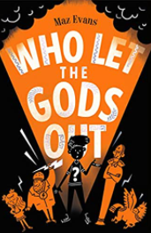 | 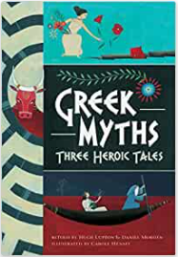 |  | 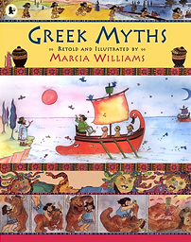
Maths
White Rose Maths – Multiplication & Division  Perimeter & Area  - Multiples  - Factors  - Common factors  - Prime numbers  - Square numbers  - Cube numbers  - Multiply by 10, 100 & 1000  - Divide by 10, 100 & 1000  - Multiples of 10, 100 & 1000 |  | White Rose Maths – Perimeter & Area  - Measure perimeter  - Perimeter on a grid  - Perimeter of rectangles  - Perimeter of rectilinear shapes  - Calculate perimeter  - Counting squares  - Area of rectangles  - Area of compound shapes  - Area of irregular shapes
Science
Properties of Materials
- compare and group together everyday materials on the basis of their properties, including their hardness, solubility, transparency, conductivity (electrical and thermal), and response to magnets
- give reasons, based on evidence from comparative and fair tests, for the particular uses of everyday materials, including metals, wood and plastic
Geography/History
History – The Ancient Greeks  A study of Greek life and achievements and their influence on the western world.  - Understand where and when ancient Greece took place and about daily life there using appropriate historical language  - Use primary and secondary sources to gather information about the ancient Greek period  - Consider the reliability of the sources they use  - Demonstrate a good understanding of what life was like in Athens and Sparta  - Name some Greek gods and understand what the ancient Greeks believed and how they worshipped  - Explain what is meant by a legacy and name some legacies of ancient Greece. |  | Key Questions:  - How can we possibly know so much about the Ancient Greeks who lived over 2,500 years ago?  - What can we work out about everyday life in ancient Athens?  - Why was Athens able to be so strong in the 5th and 6th century?  - What can we tell about the Ancient Greeks from a study of their Olympics?  - In what ways have the Greeks influenced our lives today?
MFL – French
Language Angels: Tienes una mascota? - Do you have a pet?  - Repeat, recognise and attempt to spell the eight nouns (including the correct article for each) for pets in Spanish.  - Tell somebody in Spanish if they have or do not have a pet. |  | - Ask somebody else in Spanish if they have a pet.  - Tell somebody in Spanish the name of their pet.  - Attempt to create a longer phrase using the connectives Y (“and”) or PERO (“but”).
Computing
Creating Media – Vector Drawing  - To identify that drawing tools can be used to produce different outcomes  - To create a vector drawing by combining shapes  - To use tools to achieve a desired effect |  | - To recognise that vector drawings consist of layers  - To group objects to make them easier to work with  - To evaluate my vector drawing
RE
Who did Jesus say “I AM”
- identify and explain the meanings of the statements Jesus used about himself
- suggest meanings for each ‘I am’ statement and describe why each is important for Christians
- suggest what Christians might learn about God through the person of Jesus
- question what Christians believe about Jesus and begin to form their own opinions in the light of their learning
- ask questions and suggest answers about the significance of Jesus’ names for themselves or for Christians
Why is light an important sign at Christmas?
- describe what Christians mean when they say that Jesus is the ‘Light of the World’
- describe how light is used (e.g. in a Christingle) and what it represents, linking it with Christian beliefs about the person of Jesus Christ
- ask questions about the meaning of light and darkness in the context of the Christmas narrative and compare their ideas with the ideas of others
PSHE
PSHE Association – Safe relationships – Physical contact and feeling safe  - to identify what physical touch is acceptable, unacceptable, wanted or unwanted in different situations  - how to ask for, give and not give permission for physical contact  - how it feels in a person’s mind and body when they are uncomfortable  - that it is never someone’s fault if they have experienced unacceptable contact  - how to respond to unwanted or unacceptable physical contact  - that no one should ask them to keep a secret that makes them feel uncomfortable or try to persuade them to keep a secret they are worried about  - whom to tell if they are concerned about unwanted physical contact |  | Respecting ourselves and others - Responding respectfully to a wide range of people; recognising prejudice and discrimination.  - to recognise that everyone should be treated equally  - why it is important to listen and respond respectfully to a wide range of people, including those whose traditions, beliefs and lifestyle are different to their own  - what discrimination means and different types of discrimination e.g. racism, sexism, homophobia  - to identify online bullying and discrimination of groups or individuals e.g. trolling and harassment  - the impact of discrimination on individual, groups and the wider society
PE
Netball
Dance
Art/DT
Sculpture/3D – Greek pots  Exploring and Developing Ideas  •Select & record from first-hand observation, experience & imagination and explore ideas for different purposes  •Question, make thoughtful observations about starting points, select ideas to use in their artwork |  | Sculpture / 3D  - Shape, form, model and construct from observation or imagination  •Use recycled, natural and man-made materials to create a sculpture
Music
Charanga – Glockenspiel Stage 2  Learn more complex rhythm patterns.  Revise, play and read the notes C, D, E, F + G.  Learn to play these tunes:  ● Mardi Gras Groovin’  ● Two-Way Radio  ● Flea Fly  ● Rigadoon  ● Mamma Mia  Revisit these tunes from Stage 1:  ● Portsmouth  ● Strictly D  ● Play Your Music  ● Drive  Compose using the notes C, D, E, F + G |  | Perform & Share  Children can contribute to the performance by singing, playing an instrumental part, improvising or by performing their composition. Record the performance and discuss their thoughts and feelings towards  it afterwards. Did they enjoy it? What went well? What could have been better?
Resilience, Respect, Aspiration and Trust
The children will show resilience and trust through learning and performing their songs and glockenspiel parts for the Christmas concert. Through our PSHE unit they will be encouraged to respond respectfully to their peers and a wider range of people including those whose traditions, beliefs and lifestyle are different to their own. They will aspire to ask the bigger questions in RE and find out about how light is used and what it represents to Christians.

Year 5 Spring 1 – Where Will My Compass Take Me?
English
The Write Stuff
- Poetry – The Highwayman
- Non-fiction – Non-chronological report – Emperor Penguins
Guided Reading | Key Texts
 | 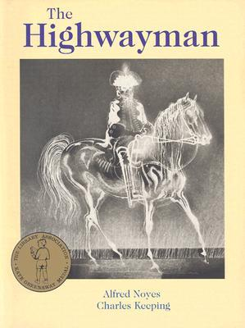 |  | 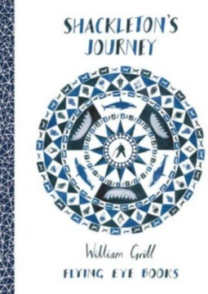
Maths
White Rose Maths – Number: Multiplication & Division  - Multiply 2-digits by 1-digit  - Multiply 3-digits by 1-digit  - Multiply 4-digits by 1-digit  - Multiply 2-digits (area model)  - Multiply 2-digits by 2-digits  - Multiply 3-digits by 2-digits  - Multiply 4-digits by 2-digits  - Divide 2-digits by 1-digit  - Divide 3-digits by 1-digit  - Divide 4-digits by 1-digit  - Divide with remainders |  | White Rose Maths – Fractions  - What is a fraction?  - Equivalent fractions  - Fractions greater than 1  - Improper fractions to mixed numbers  - Mixed numbers to improper fractions  - Number sequences  - Compare and order fractions less than 1  - Compare and order fractions greater than 1
Science
Materials
- know that some materials will dissolve in liquid to form a solution, and describe how to recover a substance from a solution
- use knowledge of solids, liquids and gases to decide how mixtures might be separated, including through filtering, sieving and evaporating
- demonstrate that dissolving, mixing and changes of state are reversible changes
- explain that some changes result in the formation of new materials, and that this kind of change is not usually reversible, including changes associated with burning and the action of acid on bicarbonate of soda
Geography/History
Geography – Maps  - Find a location on a page by using simple co-ordinates  - Use a key to identify physical features on a map  - Find a location from a six-figure co-ordinate  - Find differences between maps of the same location  - Give four-figure/six-figure co-ordinates for a location. |  | Key Questions:  - What is the difference between the British Isles, the United Kingdom and Great Britain?  - What are the main map symbols and why do we use them?  - How do you use the eight points of a compass to describe a route?  - How do you use four and six-figure grid references to locate places on a map?  - How do you plan a route using the eight compass points, four or six-figure grid references and distance using scale?
MFL – Spanish
Language Angels: Desayuno En El Café – at the café  - Order from a selection of foods from a Spanish menu.  - Order from a selection of drinks from a Spanish menu.  - Order a Spanish breakfast. |  | - Order typical Spanish snacks.  - Ask for the bill.  - Remember how to say hello, goodbye, please and thank you.
Computing
Creating Media -Video Editing  - To recognise video as moving pictures, which can include audio  - To identify digital devices that can record video  - To capture video using a digital device |  | - To recognise the features of an effective video  - To identify that video can be improved through reshooting and editing  - To consider the impact of the choices made when making and sharing a video
RE
What does it mean to be a Muslim?
- describe key moments from the life of the prophet Muhammad and explain their significance in Muslim belief
- describe how following the teaching of the Qur’an affects daily life for Muslims
- describe how teachings / words from the Qur’an or stories from the life of Muhammad might inspire Muslims and make connections with what inspires them
PSHE
Belonging to a community - Protecting the environment; compassion towards others  - about how resources are allocated and the effect this has on individuals, communities, and the environment  - the importance of protecting the environment and how everyday actions can either support or damage it  - how to show compassion for the environment, animals, and other living things  - about the way that money is spent and how it affects the environment  - to express their own opinions about their responsibility towards the environment |  | Media literacy and Digital resilience - How information online is targeted; different media types, their role and impact  - to identify different types of media and their different purposes e.g. to entertain, inform, persuade or advertise  - basic strategies to assess whether content online (e.g. research, news, reviews, blogs) is based on fact, opinion, or is biased  - that some media and online content promote stereotypes  - how to assess which search results are more reliable than others  - to recognise unsafe or suspicious content online  - how devices store and share information
PE
Gymnastics
Volleyball
Art/DT
Mechanical systems - Cams  Designing  • Generate innovative ideas by carrying out research using surveys, interviews, questionnaires and web-based resources.  • Develop a simple design specification to guide their thinking.  • Develop and communicate ideas through discussion, annotated drawings, exploded drawings and drawings from different views.  Making  • Produce detailed lists of tools, equipment and materials. Formulate step-by-step plans and, if appropriate, allocate tasks within a team.  • Select from and use a range of tools and equipment to make products that that are accurately assembled and well finished. Work within the constraints of time, resources and cost. |  | Evaluating  • Compare the final product to the original design specification.  • Test products with the intended user, where safe and practical, and critically evaluate the quality of the design, manufacture, functionality and fitness for purpose.  • Consider the views of others to improve their work.  • Investigate famous manufacturing and engineering companies relevant to the project.  Technical knowledge and understanding  • Understand that mechanical systems have an input, process and an output.  • Understand how cams can be used to produce different types of movement and change the direction of movement.  - Know and use technical vocabulary relevant to the project.
Music
Charanga Classroom Jazz 1  Style: Jazz  Listen and Appraise  Three Note Bossa  Desafinado  Cotton Tail  Five Note Swing  Perdido  Things Ain’t What They Used To Be |  | Musical Activities  Play the tune/head and the middle 8  Build on improvisation skills using instruments  Perform  Play the tune/head and the middle 8 and improvise
Resilience, Respect, Aspiration and Trust
During this unit the children aspire to make a difference to their environment and understand how their actions can either support or damage it. They will develop a respect for Muslims and their way of life and understand what might inspire them in their religion. When completing their computing unit on video editing they will have to work co-operatively with each other and trust their each other to complete their shared tasks.

Year 5 Spring 2 – Where Does All Our Stuff Come From?
English
The Write Stuff
- Biography - David Attenborough
- Narrative – The Fantastic Flying Books of Mr Morris Lessmore
Guided Reading | Key Texts
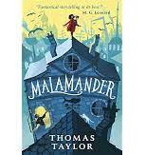 |  |  | 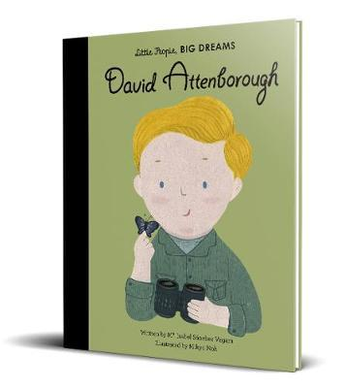
Maths
White Rose Maths – Fractions  - Add and subtract fractions  - Add fractions within 1  - Add 3 or more fractions  - Add fractions  - Add mixed numbers  - Subtract fractions  - Subtract mixed numbers  - Subtraction – breaking the whole  - Subtract 2 mixed numbers  - Multiply unit fractions by an integer  - Multiply non-unit fractions by an integer  - Multiply mixed numbers by integers  - Calculate fractions of a quantity |  | - Fraction of an amount  - Using fractions as operators  - Fraction problem solving  White Rose Maths – Decimals & Percentages  - Decimals up to 2 decimal places  - Decimals as fractions  - Understanding thousandths  - Thousandths as decimals  - Rounding decimals  - Order and compare decimals  - Understand percentages  - Percentages as fractions and decimals  - Equivalent fractions, percentages & decimals
Science
Living Things and Their Habitats
- describe the differences in the life cycles of a mammal, an amphibian, an insect and a bird
- describe the life process of reproduction in some plants and animals
Geography/History
Voyagers Geography – Where does all our stuff come from?  - Describe and understand key aspects of human geography, including: types of settlement and land use, economic activity including trade links, and the distribution of natural resources including energy, food, minerals and water.  - Use maps atlases, globes and digital/computer mapping to locate countries and describe features. |  | Key Questions:  - Where do my school uniform and lunch come from?  - Where does my fruit salad come from?  - How do my clothes get to my wardrobe?  - How has the import of products affected local industries?  - Local produce or imported produce?
MFL – French
Language Angels -  Qué Tiempo Hace? – What’s the weather like?  - Repeat and recognise the vocabulary for weather in Spanish.  - Ask what the weather is like today. |  | - Say what the weather is like today.  - Create a Spanish weather map.  - Describe the weather in different regions of Spain using a weather map with symbols.
Computing
Data & Information - Flat-File Databases
- To use a form to record information
- To compare paper and computer-based databases
- To outline how grouping and then sorting data allows us to answer questions
- To explain that tools can be used to select specific data
- To explain that computer programs can be used to compare data visually
- To apply my knowledge of a database to ask and answer real-world questions
RE
How did Jesus’ teaching challenge people?
- describe meanings for a range of Jesus’ parables & teachings and describe the impact of them on how Christians live
- apply ideas and reflections about Jesus’ teaching to their own or others’ lives e.g. which of Jesus’ teachings might be the most important
How do Christians know what happened at Easter? Easter Pause Day
- compare the similarities within the Gospel accounts of Easter, suggesting reasons for this
- relate the key events within the Easter narrative to Christian belief about Jesus
- suggest answers to questions about puzzling aspects of the death & resurrection of Jesus, making reference to the Gospel accounts
PSHE
Money and Work - Identifying job interests and aspirations; what influences career choices; workplace stereotypes
- to identify jobs that they might like to do in the future
- about the role ambition can play in achieving a future career
- how or why someone might choose a certain career
- about what might influence people’s decisions about a job or career, including pay, working conditions, personal interests, strengths and qualities, family, values
- the importance of diversity and inclusion to promote people’s career opportunities
- about stereotyping in the workplace, its impact and how to challenge it
- that there is a variety of routes into work e.g. college, apprenticeships, university, training
PE
Tennis
Swimming
Art/DT
Art – Collage
- Select and record from first-hand observations, experience and imagination and explore ideas for different purposes
- Question, make thoughtful observations about starting points, select ideas to use in their artwork and layering)
- Experiment with a range of collage techniques (tearing, overlapping and layering) to create images and represent textures
- Use collage as a means of collecting ideas and information and building a visual vocabulary
Music
Charanga - Make You Feel My Love  Style: Pop Ballads  Listen and Appraise  Make You Feel My Love – Bob Dylan  So Amazing – Luther Vandross  Hello – Lionel Richie |  | Musical Activities  Warm up games  Flexible games  Singing  Play instrumental parts  Improvise  Compose  Performance  Sing the songs and perform compositions within the songs
Resilience, Respect, Aspiration and Trust
Through our PSHE the children will develop aspirations for their future and explore a range of careers they could undertake. They will show respect for each other and Christian beliefs when finding out about the Easter story. In art they will show resilience through experimenting with a range of media to produce a collage.

Year 5 Summer 1 – It’s a Kind of Magic
English
The Write Stuff
- Narrative – Mystery – The Nowhere Emporium
- Poetry – The Malfeasance
Guided Reading | Key Texts
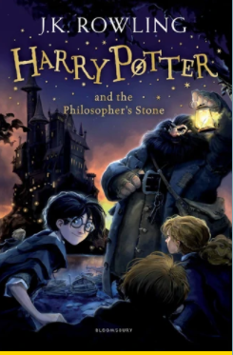 | 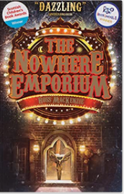 |  | 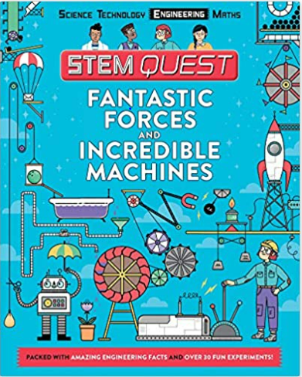
Maths
White Rose Maths – Decimals  - Adding decimals within 1  - Subtracting decimals within 1  - Complements to 1  - Adding decimals – crossing the whole  - Adding decimals with the same number of decimal places  - Subtracting decimals with the same number of decimal places  - Adding and subtracting decimals with the same number of decimal places problem solving  - Adding decimals with a different number of decimal places  - Subtracting decimals with a different number of decimal places  - Adding and subtracting decimals with a different number of decimal places problem solving  - Adding and subtracting wholes and decimals |  | - Decimal sequences  - Multiplying decimals by 10, 100 and 1,000  Dividing decimals by 10, 100 and 1,000  White Rose Maths – Properties of Shape  - Identify angles  - Compare and order angles  - Measuring angles in degrees  - Measuring with a protractor (1)  - Measuring with a protractor (2)  - Drawing lines and angles accurately  - Calculating angles on a straight line  - Triangles  - Quadrilaterals  - Calculating lengths and angles in shapes  - Regular and irregular polygons  - Reasoning about 3-D shapes
Science
Forces
- explain that unsupported objects fall towards the Earth because of the force of gravity acting between the Earth and the falling object
- identify the effects of air resistance, water resistance and friction, that act between moving surfaces
- recognise that some mechanisms, including levers, pulleys and gears, allow a smaller force to have a greater effect
Geography/History
Voyagers Geography – How is our country changing?  - Name and locate counties, cities and geographical regions of the UK  - Identify human and physical characteristics, topographical features and land-use patterns and understand how these patterns have changed over time.  - Understand geographical similarities and differences through the study of human and physical geography of a region of the United Kingdom  - Use maps, atlases, globes to located countries and build their knowledge of the UK and the wider world.  - Use fieldwork to observe, measure, record and present the human and physical features of the local area |  | Key Questions:  - Where is the United Kingdom?  - How did the 2012 Olympics change London?  - How did World War Two change the West Midlands?  - Is our local area changing?  - How will our local area change in the future?
MFL – Spanish
Language Angels: La ropa – clothes  - Repeat and recognise the vocabulary for a variety of clothes in Spanish.  - Use the appropriate genders and articles for these clothes.  - Use the verb LLEVAR in Spanish with increasing confidence. |  | - Say what they wear in different weather/situations.  - Describe clothes in terms of their colour and apply adjectival agreement.  - Use the possessives with increased accuracy
Computing
Programming A - Selection in Physical Computing  - To control a simple circuit connected to a computer  - To write a program that includes count-controlled loops  - To explain that a loop can stop when a condition is met, eg number of times |  | - To conclude that a loop can be used to repeatedly check whether a condition has been met  - To design a physical project that includes selection  - To create a controllable system that includes selection
RE
How can a mosque help us to understand the Muslim faith?  - gather, select, and organise ideas about Islam  - describe how features of a mosque / Muslim prayer reveal Muslim beliefs, using appropriate vocabulary |  | - suggest how praying or worshipping as a community might benefit Muslims / themselves  - suggest what would have to change in their classroom if it were to become a mosque
PSHE
Physical health and Mental wellbeing - Healthy sleep habits; sun safety; medicines, vaccinations, immunisations and allergies  - how sleep contributes to a healthy lifestyle  - healthy sleep strategies and how to maintain them  - about the benefits of being outdoors and in the sun for physical and mental health  - how to manage risk in relation to sun exposure, including skin damage and heat stroke  - how medicines can contribute to health and how allergies can be managed  - that some diseases can be prevented by vaccinations and immunisations  - that bacteria and viruses can affect health  - how they can prevent the spread of bacteria and viruses with everyday hygiene routines  - to recognise the shared responsibility of keeping a clean environment |  | Christopher Winter Project – Relationship Education  1. To explore the emotional and physical changes occurring in  Puberty  2 To understand male and female puberty changes in more  detail  3. To explore the impact of puberty on the body and the  importance of physical hygiene  To explore ways to get support during puberty
PE
Athletics |  | Orienteering
Art/DT
Textiles  Designing  • Generate innovative ideas by carrying out research including surveys, interviews and questionnaires.  • Develop, model and communicate ideas through talking, drawing, templates, mock-ups and prototypes and, where appropriate, computer-aided design.  • Design purposeful, functional, appealing products for the intended user that are fit for purpose based on a simple design specification.  Making  • Produce detailed lists of equipment and fabrics relevant to their tasks.  • Formulate step-by-step plans and, if appropriate, allocate tasks within a team. |  | • Select from and use a range of tools and equipment to make products that are accurately assembled and well finished. Work within the constraints of time, resources, and cost.  Evaluating  • Investigate and analyse textile products linked to their final product.  • Compare the final product to the original design specification.  • Test products with intended user and critically evaluate the quality of the design, manufacture, functionality and fitness for purpose.  • Consider the views of others to improve their work.  Technical knowledge and understanding  • A 3-D textile product can be made from a combination of accurately made pattern pieces, fabric shapes and different fabrics.  • Fabrics can be strengthened, stiffened, and reinforced where appropriate.
Music
Charanga - Fresh Prince Of Bel-Air  Style: Hip Hop  Listen And Appraise  The Fresh Prince of Bel Air  Me Myself and I – De La Soul  Ready or Not – The Fugees  Rapper’s Delight – The Sugarhill Gang |  | Musical Activities  Warm-up games  Flexible games  Singing – The Fresh Prince of Bel Air  Play instrumental parts  Improvise  Compose  Performance  Sing the song and compose compositions within the song.
Resilience, Respect, Aspiration and Trust
During this unit the children will develop a respect for the Muslim faith. Through their sessions in orienteering they will show resilience and trust and be able to work together as a team to solve problems. They will also develop resilience working together to solve problems in computing sessions.

Year 5 Summer 2 – Marvellous Maya
English
The Write Stuff
Poetry – The Malfeasance by Alan Bold
Non-fiction – Balanced argument - Screen Use
Guided Reading | Key Texts
 | 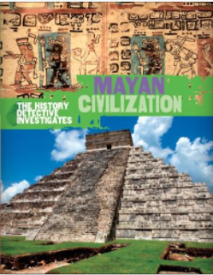 |  | 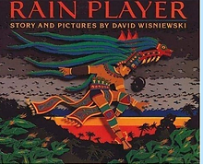
Maths
White Rose Maths – Position and Direction  - Describe position  - Position in the first quadrant  - Translation  - Translation with coordinates  - Line of symmetry  - Complete a symmetric figure  - Reflection  - Reflection with coordinates  White Rose Maths – Converting Units  - Kilometres  - Kilograms and kilometres |  | - Millimetres and millilitres  - Metric units  - Imperial units  - Converting units of time  - Timetables  White Rose Maths – Volume  - What is volume?  - Compare volume  - Estimate volume  - Estimate capacity
Science
Animals including humans
- describe the changes as humans develop to old age
- describe the stages of human development
- describe and explain the major changes that occur during puberty
Geography/History
History – The Maya Civilisation  - Develop a chronologically secure knowledge and understanding of British, local and world history, establishing clear narratives  - Address and sometimes devise historically valid questions about change, cause, similarity and difference, and significance.  - Note connections, contrasts and trends over time and develop the appropriate use of historical terms.  - Understand how our knowledge of the past is constructed from a range of sources.  - Construct informed responses that involve thoughtful selection and organisation of relevant historical information |  | Key Questions:  - Why do we study the Maya in history at KS2?  - When so much of the land they lived in was mountain and jungle, how did the Maya manage to become so important?  - What was everyday life in Mayan civilization?  - What was life like for the Mayan people 1,000 years ago?  - If the Maya were so civilized why did they carry out human sacrifice?  - How can we solve the riddle of why the Mayan empire ended so quickly?
MFL – French
Language Angels: La Familia – The family
- Say the nouns in Spanish for members of their family.
- Tell somebody in Spanish the members and age of a fictitious, historical or television family as a model to present and practise family vocabulary.
- Continue to count, reaching 100, to enable students to say the age of various family members.
- • Understand the concept of mi and mis in Spanish.
Computing
Programming B – Selection in Quizzes
- To explain how selection is used in computer programs
- To relate that a conditional statement connects a condition to an outcome
- To explain how selection directs the flow of a program
- To design a program which uses selection
- To create a program which uses selection
- To evaluate the program
RE
How do the pillars of Islam help Muslims live a good life?
- describe and connect some key Muslim beliefs about Allah, worship practices and the pillars
- describe the impact of celebrating and fasting in the life of Muslims
- explain how pilgrimage differs from other journeys
- suggest what might happen as a result of zakah (or other pillar) and consider what might motivate Muslims to give (fast, pray etc
PSHE
Growing and changing - Personal identity; recognising individuality and different qualities; mental wellbeing
- about personal identity and what contributes to it, including race, sex, gender, family, faith, culture, hobbies, likes/dislikes
- how to recognise, respect and express their individuality and personal qualities
- ways to boost their mood and improve emotional wellbeing
- about the link between participating in interests, hobbies and community groups and mental wellbeing
PE
Cricket
Handball
Art/DT
Design Technology - Food – Celebrating culture and seasonality  Designing  • Generate innovative ideas through research and discussion with peers and adults to develop a design brief and criteria for a design specification.  • Explore a range of initial ideas, and make design decisions to develop a final product linked to user and purpose.  • Use words, annotated sketches and information and communication technology as appropriate to develop and communicate ideas.  Making  • Write a step-by-step recipe, including a list of ingredients, equipment and utensils  • Select and use appropriate utensils and equipment accurately to measure and combine appropriate ingredients.  • Make, decorate and present the food product appropriately for the intended user and purpose. |  | Evaluating  • Carry out sensory evaluations of a range of relevant products and ingredients. Record the evaluations using e.g. tables/graphs/charts such as star diagrams.  • Evaluate the final product with reference back to the design brief and design specification, taking into account the views of others when identifying improvements.  • Understand how key chefs have influenced eating habits to promote varied and healthy diets.  Technical knowledge and understanding  • Know how to use utensils and equipment including heat sources to prepare and cook food.  • Understand about seasonality in relation to food products and the source of different food products.  • Know and use relevant technical and sensory vocabulary.
Music
Charanga - Dancing In The Street  Style: Motown  Listen and Appraise  - Dancing in the Street – Martha and the Vandellas  - I Can’t help myself – The Four Tops  - I Heard It Through The Grapevine – Marvin Gaye  - Ain’t No Mountain High Enough – Marvin Gaye |  | Musical Activities  - Warm-up games  - Flexible games  - Vocal warm ups  - Play instrumental parts  - Compose
Resilience, Respect, Aspiration and Trust
This term children will show respect for people’s opinions in PSHE as they discuss the subject of growing and changing. They will also show respect for each other and different cultures when celebrating culture and seasonality in Design Technology. They will also show respect and trust in each other and show resilience when performing the end of term production.

