Year 3 Autumn 1 – What was life like in the Stone Age?
English
The Write Stuff
- Fiction - The Stone Age Boy
- Non - Fiction - Skeletons and Muscles
- Poetry – Autumn is Here
Guided Reading | Key Texts
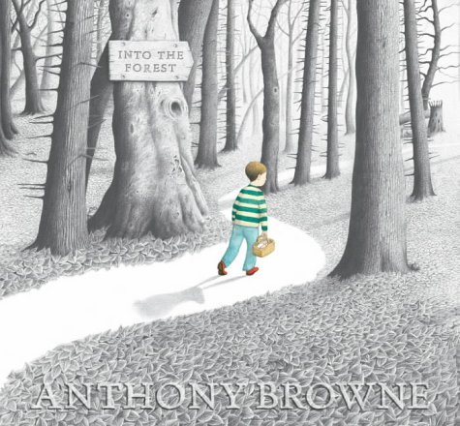 | 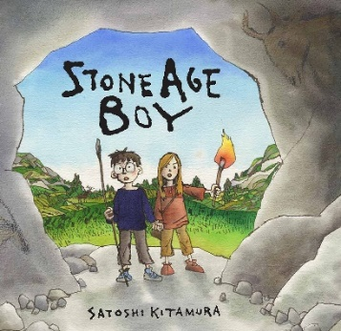 |  | 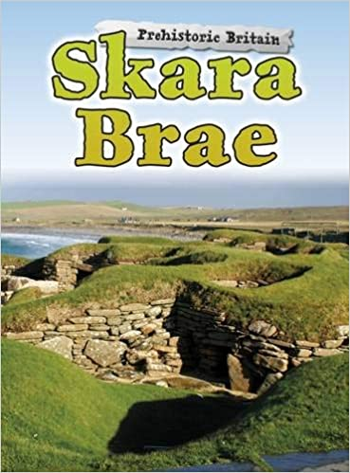
Maths
White Rose Maths – Place Value and Four Operations  - Represent numbers to 100  - Tens and ones using addition  - Hundreds  - Numbers to 1,000  - Activity Numbers to 1,000 on a place value grid  - 100s, 10s and 1s (1)  - 100s, 10s and 1s (2)  - Number line to 100  - Number line to 1,000  - Find 1, 10, 100 more or less  - Compare objects  - Compare numbers  - Order numbers  - Count in 50s  - Add and subtract multiples of 100  - Add and subtracts 1s |  | - Add and subtract 3-digit and 1-digit numbers  - Add a 2-digit and 1-digit number - crossing 10  - Add 3-digit and 1-digit numbers - crossing 10  - Subtract a 1-digit number from 2-digits - crossing 10  - Subtract a 1-digit number from a 3-digit number - crossing 10  - Add and subtract 3-digit and 2-digit numbers  - Add 3-digit and 2-digit numbers - crossing 100  - Subtract a 2-digit number from a 3-digit number - crossing 100  - Add and subtract 100s  - Spot the pattern - making it explicit  - Add two 2-digit numbers - crossing 10 - add ones & add tens  - Subtract a 2-digit number from a 2-digit number - crossing 10 - subtract ones & subtract tens  - Mixed addition and subtraction problems
Science
Keeping Healthy – Animals including humans  - Identify parts of the body including the skeleton and muscles.  - Classify and compare different types of animals.  - Explain why some animals have skeletons and muscles for support, protection, and movement. |  | - Identify that animals get nutrition from what they eat.  - Research food groups and explain how they keep us healthy.  Hands on Science: Create a nutrition plan for someone trying to be healthy.
Geography/History
Key Stage History – From Stone Age to Iron Age  - Pupils should note connections, contrasts and trends over time and develop the appropriate use of historical terms.  - Pupils should construct informed responses.  - Pupils should understand how our knowledge of the past is constructed from a range of sources.  - They should include  - late Neolithic hunter-gatherers and early farmers, for example, Skara Brae  - Bronze Age religion, technology and travel, for example, Stonehenge  - Iron Age hill forts: tribal kingdoms, farming, art and culture |  | Key Questions:  - Is it true to say that Stone Age man was just a simple hunter gatherer only interested in food and shelter? KQ1  - How much did life change when man learned how to farm? KQ2  - What can we learn about life in the Stone Age from a study of Skara Brae? KQ3  - Why did they build Stonehenge? KQ4  - What was life like in the Iron Age and how do we know? KQ5  - Iron Age Hill Fort - Who killed the 52 dead bodies at Maiden Castle? KQ6
MFL – Spanish
Language Angels – Yo Aprendo  - Identify Spain on a map of the world.  - Highlight famous Spanish cities. |  | - Talk about other countries where Spanish is spoken.  - Say their name and how they are feeling in Spanish.  - Count to ten in Spanish.
Computing
Teach Computing – Connecting Computers  - Develop their understanding of digital devices.  - Understand inputs, processes, and outputs. |  | - Compare digital and non-digital devices.  - Introduce computer networks that include network infrastructure devices like routers and switches.
RE
Comparative - How did it all begin?
Children understand;
- that many people believe God can be discovered through the awe and beauty of nature.
- some religions teach that the world was created by God.
- Christians believe that humanity is created by God to look after the world.
- that Christians, Jews and Muslims have similar beliefs about creation.
- that other religions and cultures also have stories about creation which teach stewardship of the natural world.
- that people who are not religious believe the world came into existence through natural processes and science offers the best way to understand these.
PSHE
PSHE Association –  Families and friendships  - to recognise and respect that there are different types of families, including single parents, same-sex parents, step-parents, blended families, foster and adoptive parents  - that being part of a family provides support, stability and love |  | - about the positive aspects of being part of a family, such as spending time together and caring for each other  - about the different ways that people can care for each other e.g. giving encouragement or support in times of difficulty  - to identify if/when something in a family might make someone upset or worried  - what to do and whom to tell if family relationships are making them feel unhappy or unsafe
PE
Football
Tag rugby
Art/DT
Cave Paintings - Lascaux  - Select & record from first-hand observation, experience & imagination and explore ideas for different purposes.  - Question, make thoughtful observations about starting points, select ideas to use in their artwork.  - Explore the roles and purposes of artists, craftspeople and designers working in different times and cultures.  - Experiment with ways in which surface detail can be added to drawings.  - Use sketchbooks to collect and record visual information from different sources.  - Draw for a sustained period of time at an appropriate level. |  | - Make lines and marks with a wide range of drawing implements.  - Experiment with different grades of pencil to draw different lines, forms, and shapes and to achieve variations of tone.  - Apply a simple use of pattern and texture in a drawing.  - Compare ideas, methods, and approaches in their own and others’ work and say what they think and feel about them.  - Adapt their work according to their views and describe how they might develop it further.  - Annotate work in sketchbook.
Music
Charanga - Let Your Spirit Fly  - To know five songs from memory and who sang them or wrote them.  - To know the style of the five songs.  - To choose one song and be able to talk about:  - Its lyrics: what the song is about  - Any musical dimensions featured in the song, and where they are used (texture, dynamics, tempo, rhythm and pitch)  - Identify the main sections of the song (introduction, verse, chorus etc.)  - Name some of the instruments they heard in the song  - To confidently identify and move to the pulse.  - To think about what the words of a song mean.  - To take it in turn to discuss how the song makes them feel. |  | - Listen carefully and respectfully to other people’s thoughts about the music.  To know and be able to talk about:  - Performing is sharing music with other people, an audience  - A performance doesn’t have to be a drama! It can be to one person or to each other  - You need to know and have planned everything that will be performed  - You must sing or rap the words clearly and play with confidence  - A performance can be a special occasion and involve an audience including of people you don’t know  - It is planned and different for each occasion  - It involves communicating feelings, thoughts, and ideas about the song/music
Resilience, Respect, Aspiration and Trust
Throughout this unit the children have aspired to explore the Stone Age period and find out how people lived and why it is important to know about their development. In learning about how the Stone Age people lived, the children are respecting the past, as well as respecting differences in the ways that people live. Showing respect for different forms of art, the children aspire to create their own piece of ‘cave painting’ using various techniques and materials.

Year 3 Autumn 2 – Does the Earth shake, rattle, and roll?
English
The Write Stuff
- Non-Fiction – Street beneath my feet
- Fiction – The Blue Umbrella
Guided Reading | Key Texts
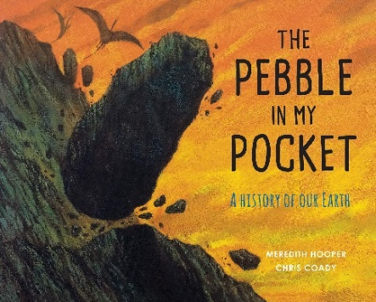 | 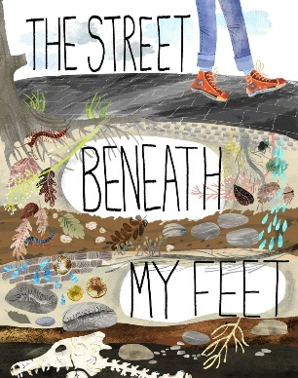 |  | 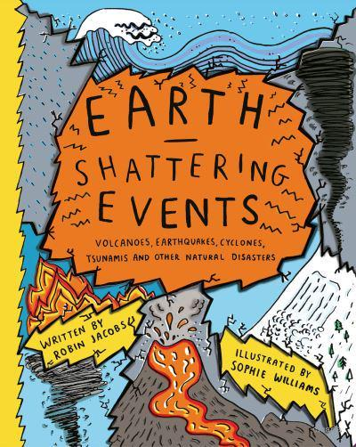
Maths
White Rose Maths – The Four Operations  - Add and subtract 2-digit and 3-digit numbers - not crossing 10 or 100  - Add 2-digit and 3-digit numbers - crossing 10 or 100  - Subtract a 2-digit number from a 3-digit numbers - crossing 10 or 100  - Add two 3-digit numbers - not crossing 10 or 100  - Add two 3-digit numbers - crossing 10 or 100  - Subtract a 3-digit number from a 3-digit number - no exchange  - Subtract a 3-digit number from a 3-digit number - exchange  - Estimate answers to calculations  - Check answers  - Multiplication - equal groups  - Multiplication using the symbol |  | - Using arrays  - 2 times-table  - 5 times-table  - Make equal groups - sharing  - Make equal groups - grouping  - Divide by 2, 5 ,10  - Multiply by 3  - Divide by 3  - The 3 times-table  - Multiply by 4  - Divide by 4  - The 4 times-table  - Multiply by 8  - Divide by 8  - The 8 times-table
Science
Rocks and Fossils –  - Classify and compare different kinds of rocks.  - Describe how fossils are formed.  - Recognise that soils are made from rocks and organic matter. |  | - Conduct investigations with some application of variables to ensure a test is fair.  - Collect, record, and analyse data from investigations.  - Use results to draw conclusions.  Hands on Science: Create a rock museum
Geography/History
Voyagers Geography – Can the earth shake, rattle, and roll?  - Describe and understand the key aspects of volcanoes and earthquakes  - Understand that the distribution of earthquakes and volcanoes follows a pattern  - Learn about the ‘Pacific Ring of Fire’. |  | Key Questions:  - What is happening when the earth shakes?  - What is happening when the earth rattles and rolls?  - Does the earth shake, rattle and roll all over?  - How and why do people live where the earth shakes, rattles and rolls?  - How disastrous have recent earthquakes and volcanic eruptions been?  - Can we make a model volcano that erupts?
MFL – Spanish
Language Angels – Los Animales  - Be introduced to ten animals in Spanish  - Match all the new Spanish words to the appropriate picture |  | - Remember the words for at least five animals in Spanish unaided  - Attempt to spell at least three animals correctly in Spanish
Computing
Teach Computing - Animation  - Learn a range of techniques to create a stop-frame animation using tablets. |  | - Apply skills to create a story-based animation.  - Learn to add different aspects of media such as music and text.
RE
Christianity - How does the Bible reveal God’s rescue plan?  Children will learn;  - the Bible contains events for which there is historical evidence  - the Bible can be read in many different formats and languages  - that the books in the Bible were written at different times and by different people  That Christians believe that:  - the Bible reveals the character and purposes of God  - the Bible is the living word of God and tells his story  - that this story of salvation has an impact on Christians’ lives |  | Christianity – Why are presents given at Christmas – and what might Jesus think?  - about the significance of the gifts and what they say about Christian belief about Jesus  - o Gold – a gift for a king  - o Frankincense – for a priest  - o Myrrh – for burial  that Christians believe:  - that God values human beings above anything else, which is why Jesus came, as a gift, to earth  - that Christmas has become over-commercialised, which detracts from its true meaning
PSHE
PSHE Association –  Safe relationships  - What is appropriate to share with friends, classmates, family and wider social groups including online  - About what privacy and personal boundaries are, including online  - Basic strategies to help keep themselves safe online e.g. passwords, using trusted sites and adult supervision  - That bullying and hurtful behaviour is unacceptable in any situation  - About the effects and consequences of bullying for the people involved  - About bullying online, and the similarities and differences to face-to-face bullying |  | - What to do and whom to tell if they see or experience bullying or hurtful behaviour  Respecting ourselves and others  - To recognise respectful behaviours e.g. helping or including others, being responsible  - How to model respectful behaviour in different situations e.g. at home, at school, online  - The importance of self-respect and their right to be treated respectfully by others  - What it means to treat others, and be treated, politely  - The ways in which people show respect and courtesy in different cultures and in wider society
PE
- Netball |  | - Dance
Art/DT
Create a Shell Structure of a Volcano using Computer Aided Design (CAD)  Designing  - Generate realistic ideas and design criteria collaboratively through discussion, focusing on the needs of the user and the functional and aesthetic purposes of the product.  - Develop ideas through the analysis of existing shell structures and use computer-aided design to model and communicate ideas.  Making  - Plan the order of the main stages of making.  - Select and use appropriate tools and software to measure, mark out, cut, score, shape and assemble with some accuracy.  - Explain their choice of materials according to functional properties and aesthetic qualities. |  | - Use computer-generated finishing techniques suitable for the product they are creating.  Evaluating  - Investigate and evaluate a range of existing shell structures including the materials, components and techniques that have been used.  - Test and evaluate their own products against design criteria and the intended user and purpose.  Technical knowledge and understanding  - Develop and use knowledge of nets of cubes and cuboids and, where appropriate, more complex 3D shapes.  - Develop and use knowledge of how to construct strong, stiff shell structures.  - Know and use technical vocabulary relevant to the project.
Music
Charanga – Glockenspiel Stage 1  To know and be able to talk about improvisation:  - Improvisation is making up your own tunes on the spot  - When someone improvises, they make up their own tune that has never been heard before. It is not written down and belongs to them  - To know that using one or two notes confidently is better than using five |  | - Different ways of recording compositions (letter names, symbols, audio etc.)  - Help create at least one simple melody using one, three or five different notes.  - Plan and create a section of music that can be performed within the context of the unit song.  - Listen to and reflect upon the developing composition and make musical decisions about pulse, rhythm, pitch, dynamics and tempo.
Resilience, Respect, Aspiration and Trust
Throughout this term, the children compose their own piece of music within a group. In this task the children need to trust each other to share ideas and develop their ideas. In working together and respecting each other, they will be able to perform together as a group to the class. In our PSHE units this term, the children explore and learn about respectful behaviours, what it means to respect someone and why respect is important. This culminates in Anti-Bullying Week, a key moment in Year 3, as the children become more independent and form their ideas about self-respect.

Year 3 Spring 1 – Do opposites attract?
English
The Write Stuff
- Fiction – The Building Boy
- Non-Fiction – How a Robot Dog Works
Guided Reading | Key Texts
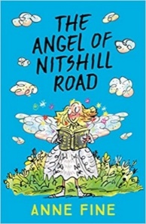 | 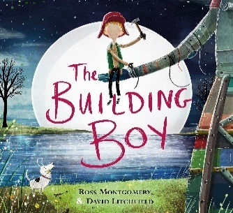 |  | 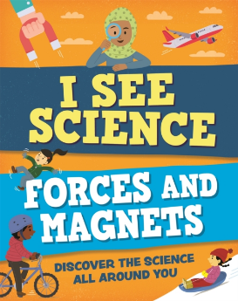
Maths
White Rose Maths – The Four Operations, Money, and Statistics  - Consolidate 2, 4 and 8 times-table (new worksheet)  - Comparing statements  - Related calculations  - Activity Multiply 2-digits by 1-digit - no exchange  - Multiply 2-digits by 1-digit (1)  - Activity Multiply 2-digits by 1-digit - exchange  - Multiply 2-digits by 1-digit (2)  - Divide 2-digits by 1-digit (1)  - Divide 2-digits by 1-digit (2)  - Activity Divide 100 into 2, 4, 5 and 10 equal parts  - Activity Divide with remainders  - Divide 2-digits by 1-digit (3)  - Scaling  - How many ways? |  | - Count money (pence)  - Count money (pounds)  - Pounds and pence  - Convert pounds and pence  - Add money  - Subtract money  - Give change  - Make tally charts  - Draw pictograms (2, 5 and 10)  - Interpret pictograms (2, 5 and 10)  - Pictograms (use for extra consolidation if needed)  - Activity Draw bar charts  - Bar charts  - Tables
Science
Amazing Magnets – Forces and Magnets
- Compare how things move on different surfaces.
- Observe how magnets attract or repel.
- Compare and classify everyday materials based on whether they are attracted to a magnet.
- Identify some magnetic materials and describe magnets as having two poles.
- Predict whether two magnets will attract or repel each other.
Hands on Science: Create a magnetic game.
Geography/History
Voyagers Geography – Where on Earth are we?  - Improve their locational knowledge through identifying the position and significance of latitude, longitude, Equator, Northern Hemisphere, Southern Hemisphere, the Tropics of Cancer and Capricorn, Arctic and Antarctic Circle, the Prime/Greenwich Meridian and time zones (including day and night).  - Practise geographical skills through using maps, atlases, globes, and digital/computer mapping to locate features studied.  - Use the eight points of the compass to build their knowledge of the wider world. |  | Key Questions:  - What is the world like?  - How can we describe where places are on the Earth’s surface?  - What do the lines on maps and globes mean?  - Why do we have night and day?  - What time is it where you are?  - What is the significance of latitude and longitude?
MFL – Spanish
Language Angels – Los Instrumentos
- Name ten instruments in Spanish.
- Match all the new Spanish words to the appropriate picture.
- Remember the words for at least five instruments and their correct gender in Spanish, unaided.
- To say that they play an instrument, of their choice correctly in Spanish.
Computing
Teach Computing – Desktop Publishing
- Children will use text and images and understand that they can be used to communicate messages.
- They will use desktop publishing software and consider careful choices of font size, colour and type to edit and improve premade documents.
- They will use the terms ‘templates’, ‘orientation’, and ‘placeholders’ and begin to understand how these can support them in making their own template for a magazine front cover.
- They will look at a range of page layouts thinking carefully about the purpose of these and evaluate how and why desktop publishing is used in the real world.
RE
Judaism - What are important times for Jews?
- that Jews mark stages in life through special ceremonies such as Bar / Bat Mitzvah and weddings
- that Pesach (Passover) recalls the events of the Exodus and is celebrated each year with the Seder meal
- that Sukkot is a Jewish harvest festival and recalls God’s provision in the desert
- that Rosh Hashanah celebrates Jewish New Year
- that Yom Kippur (Day of Atonement) is a time for repentance and forgiveness
PSHE
PSHE Association –  Belonging to a community  - The reasons for rules and laws in wider society  - The importance of abiding by the law and what might happen if rules and laws are broken  - What human rights are and how they protect people  - To identify basic examples of human rights including the rights of children about how they have rights and also responsibilities  - That with every right there is also a responsibility e.g. the right to an education and the responsibility to learn |  | Media Literacy and Digital Resilience  - How the internet can be used positively for leisure, for school and for work  - To recognise that images and information online can be altered or adapted and the reasons for why this happens  - Strategies to recognise whether something they see online is true or accurate  - To evaluate whether a game is suitable to play or a website is appropriate for their age-group  - To make safe, reliable choices from search results  - How to report something seen or experienced online that concerns them e.g. images or content that worry them, unkind or inappropriate communication
PE
Gymnastics |  | Volleyball
Art/DT
Mechanical Systems, Pneumatics – Create a game using forces  Designing  - Generate realistic and appropriate ideas and their own design criteria through discussion, focusing on the needs of the user.  - Use annotated sketches and prototypes to develop, model and communicate ideas.  Making  - Order the main stages of making.  - Select from and use appropriate tools with some accuracy to cut and join materials and components such as tubing, syringes and balloons. |  | - Select from and use finishing techniques suitable for the product they are creating.  Evaluating  - Investigate and analyse books, videos and products with pneumatic mechanisms.  - Evaluate their own products and ideas against criteria and user needs, as they design and make.  Technical knowledge and understanding  - Understand and use pneumatic mechanisms.  - Know and use technical vocabulary relevant to the project.
Music
Charanga – Three little Birds  - To confidently identify and move to the pulse.  - Listen carefully and respectfully to other people’s thoughts about the music.  Know how to find and demonstrate the pulse.  - Know the difference between pulse and rhythm.  - Know how pulse, rhythm and pitch work together to create a song.  - Know that every piece of music has a pulse/steady beat. |  | - Singing in a group can be called a choir  - To know why you must warm up your voice  - To sing in unison and in simple two-parts.  - To demonstrate a good singing posture.  - To follow a leader when singing.  - To enjoy exploring singing solo.  - To sing with awareness of being ‘in tune’.  - To have an awareness of the pulse internally when singing.
Resilience, Respect, Aspiration and Trust
During this unit the children show resilience and work as a team to build their own board game using varying forces. As part of working in a team, they will respect each other to share their ideas and opinions and trust each other to be successful in their game. When exploring how magnets work, the children will aspire to find out as much as possible in order to be able to predict how a magnet will respond to different materials.

Year 3 Spring 2 – How does water go round and round?
English
The Write Stuff
- Fiction – Flood by Alvaro F. Villa
- Poetry – I asked a little boy who cannot see
Guided Reading | Key Texts
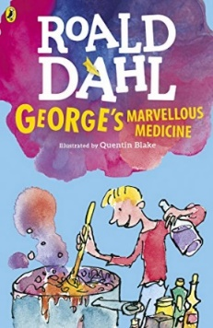 | 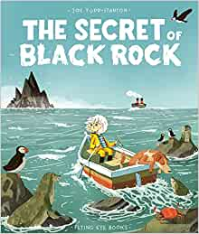 |  | 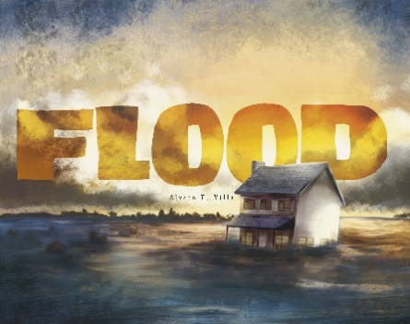
Maths
White Rose Maths – Length, Perimeter and Fractions  - Measure length  - Measure length (m)  - Equivalent lengths - m & cm  - Equivalent lengths - mm & cm  - Compare lengths  - Compare lengths  - Add lengths  - Subtract lengths  - Activity What is perimeter?  - Measure perimeter  - Calculate perimeter  - Activity Calculate perimeter activity |  | - Activity Working with wholes and parts  - Make equal parts  - Recognise a half  - Find a half  - Recognise a quarter  - Find a quarter  - Recognise a third  - Find a third  - Unit fractions  - Non-unit fractions  - Unit and non-unit fractions (use for consolidation if needed)  - Equivalence of a half and 2 quarters  - Count in fractions
Science
Roots and Shoots – Plants  - Identify and describe the functions of different parts of flowering plants.  - Explore the requirements of plants for life and growth. |  | - Investigate the way in which water is transported within plants.  - Explore the part that flowers play in the life cycle of flowering plants.  Hands on Science: Grow our own bean plants.
Geography/History
Voyagers Geography – How does water go round and round?  - Name and locate (some of) the UK’s most significant rivers and mountain environments  - Describe features of a river and a mountain environment in the UK  - Learn how rivers and mountains are formed  - Understand where rivers and mountains fit into the water cycle. |  | Key Questions:  - Where does all the rain go?  - Where does all of the rainfall come from?  - What can we learn about the River Thames?  - How and why do people change rivers?  - How do rivers wear away mountains?  - How can we model a river or stream?
MFL – Spanish
Language Angels – La Fruta  - Name and recognise up to 10 fruits in Spanish.  - Attempt to spell some of these nouns. |  | - Ask somebody in Spanish if they like a particular fruit.  - Say what fruits they like and dislike.
Computing
Teach Computing – Branching databases
- Children will develop their understanding of what a branching database is and how to create one.
- They will gain an understanding of what attributes are and how to use them to sort groups of objects.
- They will create physical and on-screen branching databases.
- They will evaluate the effectiveness of branching databases and will decide what types of data should be presented as a branching database.

RE
Christianity - How did Jesus change lives?
- that Jesus befriended ordinary people e.g. fishermen, and the ‘outcasts’ of society e.g. tax collectors, lepers, women
Christians believe that:
- encountering Jesus changed the lives of people who met him
- Jesus showed he was God’s Son by performing miracles
- each miracle reveals something different about who Jesus is
- what impact these events might have on Christians today
Christianity - What happened – and what matters most to Christians?
Children will learn about the events of Holy Week and Easter Sunday and their significance for Christians:
- Palm Sunday (e.g. triumphal entry, money changers)
- Maundy Thursday (e.g. foot washing, Passover meal)
- Good Friday (e.g. trial and crucifixion) & Easter Sunday (e.g. resurrection)
- about the symbols associated with Easter and their links with what Christians believe about Jesus as King and Saviour (e.g. palm crosses; cross/crucifix; purple robes; bread and wine)
- about the links between Passover and Easter
PSHE
PSHE Association –  Money and Work  - About jobs that people may have from different sectors e.g. teachers, business people, charity work  - That people can have more than one job at once or over their lifetime  - About common myths and gender stereotypes related to work |  | - To challenge stereotypes through examples of role models in different fields of work e.g. women in STEM  - About some of the skills needed to do a job, such as teamwork and decision-making  - To recognise their interests, skills and achievements and how these might link to future jobs  - How to set goals that they would like to achieve this year e.g. learn a new hobby
PE
Tennis |  | Dodgeball
Art/DT
River and Pond Life Art - Monet  - Select & record from first-hand observation, experience & imagination and explore ideas for different purposes.  - Question, make thoughtful observations about starting points, select ideas to use in their artwork.  - Explore the roles and purposes of artists, craftspeople and designers working in different times and cultures.  - Draw for a sustained period of time at an appropriate level.  - Experiment with different grades of pencil to draw different lines, forms and shapes and to achieve variations of tone.  - Begin to show an awareness in their drawings that objects have a 3rd dimension.  - Mix colours and know which primary colours make secondary colours. |  | - Mix and use tints and shades.  - Use more specific colour language.  - Experiment with different textures and effects inc. blocking colour, washes, thickened paint.  - Work on a range of scales e.g. thin brush on a small picture.  - Compare ideas, methods and approaches in their own and others’ work and say what they think and feel about them.  - Adapt their work according to their views and describe how they might develop it further.  - Annotate work in sketchbook.
Music
Charanga – The Dragon Song  - To know five songs from memory and who sang them or wrote them.  - To know the style of the five songs.  - To choose one song and be able to talk about:  ○ Its lyrics: what the song is about  ○ Any musical dimensions featured in the song, and where they are used (texture, dynamics, tempo, rhythm and pitch)  ○ Identify the main sections of the song (introduction, verse, chorus etc.)  ○ Name some of the instruments they heard in the song  - To confidently identify and move to the pulse. |  | - To think about what the words of a song mean.  - To take it in turn to discuss how the song makes them feel.  - Listen carefully and respectfully to other people’s thoughts about the music.  - To know and be able to talk about: The instruments used in class (a glockenspiel, a recorder)  - To treat instruments carefully and with respect.  - Play any one, or all of four, differentiated parts on a tuned instrument – a one-note, simple or medium part or the melody of the song) from memory or using notation.  - To rehearse and perform their part within the context of the Unit song.
Resilience, Respect, Aspiration and Trust
Within this unit the children learn to respect the different forces of nature, in understanding the water cycle, rainfall and where it all comes from. When completing their scientific experiment, understanding the effect of various requirements for a plant’s growth, they will need to trust each other, that everyone in the group will consistently take turns in giving the plants the requirements chosen, even when they can see the effects they are having on the seeds growth. The children will aspire to show an impressionistic style in their art, showing their idea of nature, particularly a body of water such as a pond or river.

Year 3 Summer 1 – Light and Shadow, what is it?
English
The Write Stuff
- Fiction – The Magic Paintbrush
- Non-Fiction – My Strong Mind
Guided Reading | Key Texts
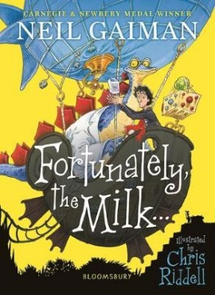 | 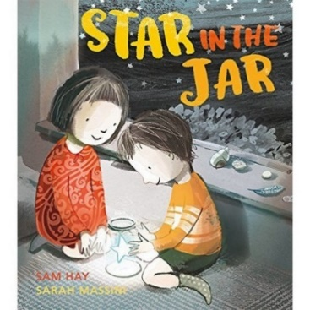 |  | 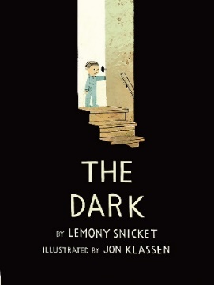
Maths
White Rose Maths – Fractions and Time  - Making the whole  - Tenths  - Count in tenths  - Tenths as decimals  - Fractions on a number line  - Fractions of a set of objects (1)  - Fractions of a set of objects (2)  - Fractions of a set of objects (3)  - Equivalent fractions (1)  - Equivalent fractions (2)  - Equivalent fractions (3)  - Compare fractions  - Order fractions  - Add fractions  - Subtract fractions |  | - O'clock and half past  - Quarter past and quarter to  - Months and years  - Hours in a day  - Telling the time to 5 minutes  - Telling the time to the minute  - Using a.m. and p.m.  - Activity 24-hour clock  - 24-hour clock  - Finding the duration  - Comparing durations  - Start and end times  - Measuring time in seconds  - Problem solving with time
Science
Light and Shadows – Light
- Investigate that we need light in order to see things.
- Consider how light is reflected from surfaces.
- Recognise that light from the sun can be dangerous.
- Explore how shadows are formed.
- Identify patterns in the way that the size of a shadow changes.
Hands on Science: Create our own shadow puppet theatre
MFL – Spanish
Language Angels - Puedo
- Recognise some common Spanish verbs/activities.
- Use these verbs to convey meaning in English by matching them to their appropriate picture.
- Use these verbs in the infinitive with puedo...
Computing
Teach Computing – Sequence in Music
- Understand the concept of sequencing in programming through Scratch.
- Children will be introduced to a selection of motion, sound, and event blocks which they will use to create their own programs, featuring sequences.
- Children apply stages of program design to make a representation of an instrument.
RE
Christianity - How did the Church begin?
Children will learn about
- the significance of the events of Pentecost
- the key features of the life of the Church at its beginning
- how the Church began to spread
- about Peter and Paul’s work to establish the Church
- that Christian symbols for the Holy Spirit include the flame and the dove, and have their origins in the events of Pentecost
- what most Christians believe about the Holy Spirit
Christianity - Why do Christians share communion?
Children will learn about
- that communion is linked to the Passover meal
- about the story of the Last Supper and what Jesus said to the disciples
- that the symbols of communion are a way of remembering Jesus and his sacrifice
- that by sharing communion as a group Christians are showing unity
- to reflect on the meaning of some actions and words involved
PSHE
PSHE Association –
Physical Health and Mental Wellbeing
- About the choices that people make in daily life that could affect their health
- To identify healthy and unhealthy choices (e.g. in relation to food, exercise, sleep)
- What can help people to make healthy choices and what might negatively influence them
- About habits and that sometimes they can be maintained, changed or stopped
- The positive and negative effects of habits, such as regular exercise or eating too much sugar, on a healthy lifestyle
- What is meant by a healthy, balanced diet including what foods should be eaten regularly or just occasionally
- That regular exercise such as walking or cycling has positive benefits for their mental and physical health
- About the things that affect feelings both positively and negatively and learn strategies to identify and talk about their feelings
- About some of the different ways people express feelings e.g. words, actions, body language
- To recognise how feelings can change overtime and become more or less powerful
PE
- Athletics
- Orienteering
Art/DT
How can we use shadows in photography?
- Select & record from first-hand observation, experience & imagination and explore ideas for different purposes.
- Question, make thoughtful observations about starting points, select ideas to use in their artwork.
- Explore the roles and purposes of artists, craftspeople and designers working in different times and cultures.
- Record and collect visual information using digital cameras and video recorders.
- Create printing blocks using relief or impressed method (polystyrene tiles).
- Create repeating patterns.
- Print with 2 colour overlays.
- Compare ideas, methods and approaches in their own and others’ work and say what they think and feel about them.
- Adapt their work according to their views and describe how they might develop it further.
- Annotate work in sketchbook.
Music
Charanga – Bringing Us Together
- Know how to find and demonstrate the pulse.
- Know the difference between pulse and rhythm.
- Know how pulse, rhythm and pitch work together to create a song.
- Know that every piece of music has a pulse/steady beat.
- Know the difference between a musical question and an answer.
- To choose what to perform and create a programme.
- To communicate the meaning of the words and clearly articulate them.
- To talk about the best place to be when performing and how to stand or sit.
- To record the performance and say how they were feeling, what they were pleased with what they would change and why.
Resilience, Respect, Aspiration and Trust
During this unit the children show resilience and work as a team to build and create their own shadow theatre. As part of working a team, the children must respect each other’s opinions and trust each other to be successful. The children aspire to understand their physical health and mental wellbeing to prepare them for the future.

Year 3 Summer 2 – What did the Romans do for us?
English
The Write Stuff
- Fiction – The Incredible Book Eating Boy
- Non-Fiction – The Journal of Iliona
Guided Reading | Key Texts
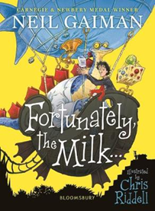 | 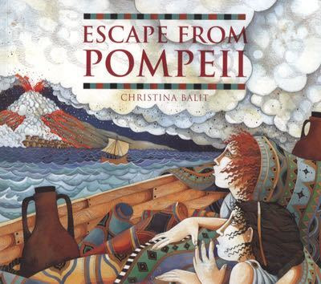 |  | 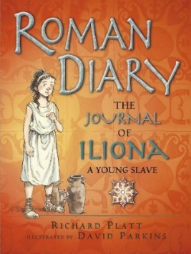
Maths
White Rose Maths – Properties of Shape, Mass, and Capacity  - Turns and angles  - Right angles in shapes  - Compare angles  - Draw accurately  - Horizontal and vertical  - Parallel and perpendicular  - Recognise and describe 2-D shapes  - Recognise and describe 3-D shapes  - Make 3-D shapes  - Measure mass |  | - Compare mass  - Measure mass  - Compare mass  - Add and subtract mass  - Activity Measure capacity  - Recap Compare volume  - Measure capacity  - Compare capacity  - Add and subtract capacity  - Activity Temperature activity  - Recap Temperature
Science
Scientists of the World –  - Scientists of the World research project.  - Investigate and research a famous scientist.  - Create a presentation of the key facts including information about their life and key aspects of their scientific discovery. |  | - Explain the impact these scientists have on our understanding of the world.  Hands on Science: Create a presentation on different scientists.
Geography/History
Key Stage History – What did the Romans ever do for us?  - Pupils should regularly address and sometimes devise historically valid questions about change, cause, similarity and difference, and significance.  - Pupils should construct informed responses that involve thoughtful selection and organisation of relevant historical information  - They will cover  - Julius Caesar’s attempted invasion in 55-54 BC  - the Roman Empire by AD 42 and the power of its army  - successful invasion by Claudius and conquest, including Hadrian’s Wall  - British resistance, for example, Boudica  - ‘Romanisation’ of Britain: sites such as Caerwent and the impact of technology, culture and beliefs, including early Christianity |  | Key Questions:  - Why did the Roman Emperor Claudius leave hot sunny Italy to invade cold wet Britain? KQ1 P1  - The Roman invasion: have the books got it right? KQ1 P2  - Should the Celts take on the Romans? KQ2 P1  - What do we know from Boudica’s rebellion? KQ2 P2  - What image do we have of Boudica today? KQ2 P3  - How were the Romans able to keep control over such a vast empire? KQ3  - Why did the Romans spend so much time building roads? KQ4 P1  - How do we know what a Roman town would like? KQ4 P2  - How can we solve the mystery of why this great 400 year empire suddenly came to an end? KQ5  - What have the Romans ever done for us? Looking at key artefacts. KQ6
MFL – Spanish
Language Angels - La historia de la antigua Gran Bretaña
- Learn and use the Spanish for “I am” (Soy), “I have” (Tengo) and “I live” (Vivo).
- Name in Spanish, the six key periods of ancient Britain, introduced in chronological order.
- Be able to say in Spanish three of the types of people who lived in ancient Britain.
- Tell somebody in Spanish the three key hunting tools used during the stone age, bronze age and iron age in ancient Britain.
- Name the three types of dwellings people lived in during the stone age, bronze age and iron age.
Computing
Teach Computing – Events and Actions  - Children will explore the links between events and actions, whilst consolidating prior learning relating to sequencing.  - Children will begin by moving a sprite in four directions. |  | - Children will explore movement within the context of a maze, using design to choose an appropriately sized sprite.  - Children will design and code their own maze tracing program.
RE
Comparative - How can we live together in One World?
Children will learn about;
- that we are all members of different communities and that our actions affect others
- that belonging to a faith community or having a non-religious world view has a global dimension
- to appreciate that there are situations of social and economic unfairness in the world
- that many religions and belief systems teach it is important to share and give to those who are in need
- that seeing the world from another person’s point of view can help make us better global citizens
PSHE
PSHE Association –  Growing and Changing  - That everyone is an individual and has unique and valuable contributions  - To make to recognise how strengths and interests form part of a person’s identity how to identify their own personal strengths and interests and what they’re proud of (in school, out of school)  - To recognise common challenges to self -worth e.g. finding school work difficult, friendship issues |  | - Basic strategies to manage and reframe setbacks e.g. asking for help, focusing on what they can learn from a setback, remembering what they are good at, trying again  Keeping safe  - How to identify typical hazards at home and in school  - How to predict, assess and manage risk in everyday situations e.g. crossing the road, running in the playground, in the kitchen  - About fire safety at home including the need for smoke alarms the importance of following safety rules from parents and other adults how to help keep themselves safe in the local environment or unfamiliar places, including road, rail, water and firework safety
PE
- Cricket
- Handball
Art/DT
2d shape to 3D Product Textiles – Create a Roman Weaving  Designing  - Generate realistic ideas through discussion and design criteria for an appealing, functional product fit for purpose and specific user/s.  - Produce annotated sketches, prototypes, final product sketches and pattern pieces.  Making  - Plan the main stages of making.  - Select and use a range of appropriate tools with some accuracy e.g. cutting, joining and finishing.  - Select fabrics and fastenings according to their functional characteristics e.g. strength, and aesthetic qualities e.g. pattern.  Evaluating |  | - Investigate a range of 3-D textile products relevant to the project.  - Test their product against the original design criteria and with the intended user.  - Take into account others’ views.  - Understand how a key event/individual has influenced the development of the chosen product and/or fabric.  Technical knowledge and understanding  - Know how to strengthen, stiffen and reinforce existing fabrics.  - Understand how to securely join two pieces of fabric together.  - Understand the need for patterns and seam allowances.  - Know and use technical vocabulary relevant to the project.
Music
Charanga – Reflect, Rewind and Replay  - Know how to find and demonstrate the pulse.  - Know the difference between pulse and rhythm.  - Know how pulse, rhythm and pitch work together to create a song.  - Know that every piece of music has a pulse/steady beat. |  | - To treat instruments carefully and with respect.  - Play any one, or all of four, differentiated parts on a tuned instrument – a one-note, simple or medium part or the melody of the song) from memory or using notation.  - To rehearse and perform their part within the context of the Unit song.
Resilience, Respect, Aspiration and Trust
During this unit the children will need resilience to plan and create their own roman weaving, aspiring to make it as authentic as possible. As they learn about growing and changing they will be learning to respect and trust themselves and each other.

