Year 2 Autumn 1 – In a Land of Magic
English
The Write Stuff
- Narrative (Story) – Stardust
- Poetry (Free Verse) – If I Were in Charge of the World
Key Texts
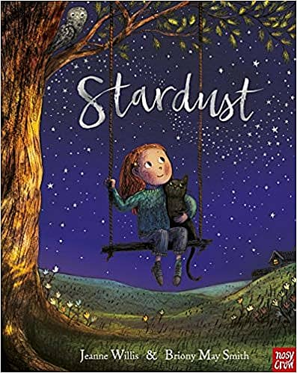 | 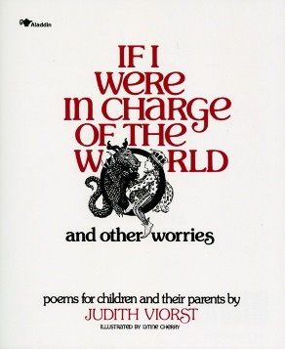 |  | 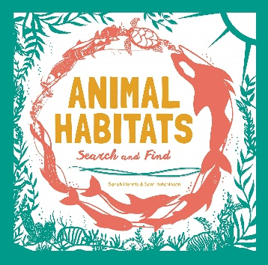
Maths
White Rose Maths – Place Value  - Counting forwards and backwards within 20  - Tens and ones within 20  - Counting forwards and backwards within 50 (Numbers to 50)  - Tens and ones within 50  - Compare numbers within 50  - Count objects to 100 and read and write numbers in numerals and words  - Count objects to 100 and read and write numbers in numerals and words  - Represent numbers to 100  - Tens and ones with a part-whole model  - Tens and ones using addition  - Use a place value chart  - Compare objects | - Compare numbers  - Order objects and numbers  - Count in 2s, 5s and 10s  - Count in 3s  White Rose Maths – Addition and Subtraction  - Fact families - addition and subtraction bonds to 20  - Check calculations  - Compare number sentences  - Know your bonds  - Related facts  - Bonds to 100 (tens)  - Add and subtract 1s  - 10 more and 10 less  - Add and subtract 10s  - Add by making 10  - Add a 2-digit and 1-digit number - crossing ten  - Subtraction - crossing 10 |  | - Subtract a 1-digit number from a 2-digit number - crossing ten  - Add two 2-digit numbers - not crossing ten - add ones and add tens  - Add two 2-digit numbers - crossing ten - add ones and add tens  - Subtract a 2-digit number from a 2-digit number - not crossing ten  - Subtract a 2-digit number from a 2-digit number - crossing ten - subtract ones and subtract tens  - Find and make number bonds  - Bonds to 100 (tens and ones)  - Add three 1-digit numbers
Science
Hamilton Trust – Habitats
- Identify that most living things live in habitats to which they are suited and describe how different habitats provide for the basic needs of different kinds of animals and plants, and how they depend on each other.
- Identify and name a variety of plants and animals in their habitats, including microhabitats.
Create a house to keep a fairy / elf warm and dry
Geography/History
Voyagers Geography – What are the Seven Wonders of Our World?  - Name, locate and identify characteristics of the seven continents and oceans  - Use world maps, atlases and globes  - Understand geographical similarities and differences when studying both human and physical geography  - Identify the locations of hot and cold areas around the world  - Use basic vocabulary to refer to physical and human features  - Develop knowledge about the world |  | Key Questions:  - What are our local wonders?  - Are mountains wonders of the world?  - Which rivers and deserts are natural world wonders?  - What are the ancient world wonders?  - Which new places are world wonders?
Computing
Teach Computing.org – Computing systems and networks – IT around us  - What is IT?  - IT in school  - IT in the world |  | - The benefits of IT  - Using IT safely  - Using IT in different ways
RE
Christianity – Why is the Bible an important book for Christians?
- Pupils should learn that that all human life is valuable / precious
- Pupils should learn that every child has a right to have their basic needs met (e.g. shelter, care, water, food, education)
- Pupils should learn to appreciate that with rights comes responsibility
- Pupils should learn that we can all make a difference in our world, whatever we believe
- Pupils should learn that Christians, Jews and Muslims believe:
  - every child matters to God
  - ‘fairness’ (justice) is important to God
PSHE
PSHE – Families and friendships
- Pupils learn how to be a good friend, e.g. kindness, listening, honesty
- Pupils learn about different ways that people meet and make friends
- Pupils learn strategies for positive play with friends, e.g. joining in, including others, etc.
- Pupils learn about what causes arguments between friends
- Pupils learn how to positively resolve arguments between friends
- Pupils learn how to recognise, and ask for help, when they are feeling lonely or unhappy or to help someone else
PE
- Hockey
- Tag Rugby
Art/DT
Projects on a Page – Textiles – Templates and joining techniques
Designing
- Design a functional and appealing product for a chosen user and purpose based on simple design criteria.
- Generate, develop, model and communicate their ideas as appropriate through talking, drawing, templates, mock-ups and information and communication technology.
Making
- Select from and use a range of tools and equipment to perform practical tasks such as marking out, cutting, joining and finishing.
- Select from and use textiles according to their characteristics.
Evaluating
- Explore and evaluate a range of existing textile products relevant to the project being undertaken.
- Evaluate their ideas throughout and their final products against original design criteria.
Technical knowledge and understanding
- Understand how simple 3-D textile products are made, using a template to create two identical shapes.
- Understand how to join fabrics using different techniques e.g. running stitch, glue, over stitch, stapling.
- Explore different finishing techniques e.g. using painting, fabric crayons, stitching, sequins, buttons and ribbons.
- Know and use technical vocabulary relevant to the project.
Music
Charanga – I Wanna Play in a Band
Singing
- Learn about voices singing notes of different pitches (high and low).
- Learn that they can make different types of sounds with their voices – you can rap (spoken word with rhythm).
Playing
- Treat instruments carefully and with respect.
- Learn to play a tuned instrumental part that matches their musical challenge, using one of the differentiated parts (a one-note, simple or medium part).
Resilience, Respect, Aspiration and Trust
During PSHE this half term, children will learn how to show respect to their peers. They will talk about how and when to ask trusted adults for help when they are feeling unhappy. They will begin to learn about religions other than Christianity and will learn to respect their views and beliefs.

Year 2 Autumn 2 – Fire and Ice
English
The Write Stuff
- Non-Fiction (Diary) – The Great Fire of London
- Narrative (Story) – My Christmas Star by The BBC
Key Texts
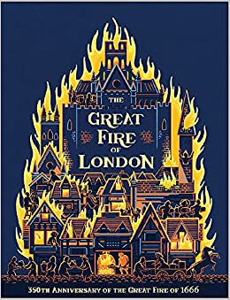 | 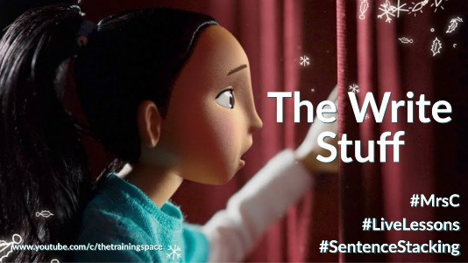 |  | 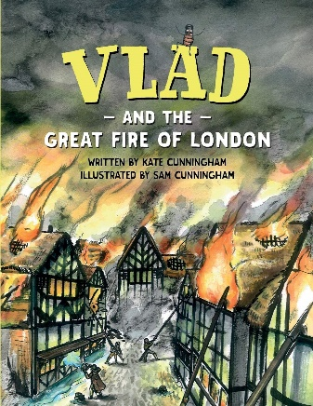
Maths
White Rose Maths – Money  - Recognising coins and notes  - Count money - pence  - Count money - pounds (notes and coins)  - Count money - notes and coins  - Select money  - Make the same amount  - Compare money  - Find the total  - Find the difference  - Find change  - Two-step problems |  | White Rose Maths – Multiplication and Division  - Make equal groups  - Recap Add equal groups  - Recap Make arrays
Science
Hamilton Trust – Materials Matter
- Identify and compare the suitability of a variety of everyday materials, including wood, metal, plastic, glass, brick, rock, paper and cardboard for particular uses..
Create a Tudor house made of flammable materials
Geography/History
Key Stage History – The Great Fire of London  - Pupils should be taught about events beyond living memory that are significant nationally or globally [for example, the Great Fire of London, the first aeroplane flight or events commemorated through festivals or anniversaries]  - Pupils should be taught about significant historical events, people and places in their own locality. |  | Key Questions:  - What happened during the Great Fire and how do we know?  - Why did the Great Fire burn down so many houses?  - How shall we rebuild London after the Great Fire?  - Why did the Great Fire of 1666 burn down so many more houses than other fires in London at that time?
Computing
Teach Computing.org – Creating media – Digital photography  - Taking photographs  - Landscape or portrait?  - What makes a good photograph? |  | - Lighting  - Effects  - Is it real?
RE
Christianity – Why is the Bible an important book for Christians?
- Pupils should learn that books can be special / important to people
- Pupils should learn that the Bible contains ‘stories’** about God and people
- Pupils should learn about some key narratives from the Old Testament e.g. Jacob, Joseph, Moses, Joshua, David, Samuel, Daniel etc.
- Pupils should learn that the New Testament contains accounts from the life of Jesus & the early Churc
- Pupils should learn that Christians read the Bible to learn about God and that this affects how they live their lives
Christianity –What does the Christmas story tell Christians about Jesus?
- Pupils should learn that Christmas is the celebration of Jesus’ birth
- Pupils should learn that Christians believe there are clues in the story that show who Jesus is
- Pupils should learn what these clues show e.g.
  - star – the birth of a new King
  - presents – Jesus as God’s gift to the world & the gifts of the Magi
  - angels – messengers from God who told people about Jesus being God’s Son
  - light – Jesus as the light of the world
PSHE
PSHE – Safe Relationships
- Pupils learn how to recognise hurtful behaviour, including online
- Pupils learn what to do and whom to tell if they see or experience hurtful behaviour, including online
- Pupils learn about what bullying is and different types of bullying
- Pupils learn how someone may feel if they are being bullied
- Pupils learn about the difference between happy surprises and secrets that make them feel uncomfortable or worried, and how to get help
- Pupils learn how to resist pressure to do something that feels uncomfortable or unsafe
- Pupils learn how to ask for help if they feel unsafe or worried and what vocabulary to use
PSHE – Respecting Ourselves and Others
- Pupils learn about the things they have in common with their friends, classmates, and other people
- Pupils learn how friends can have both similarities and differences
- Pupils learn how to play and work cooperatively in different groups and situations
- Pupils learn how to share their ideas and listen to others, take part in discussions, and give reasons for their views
PE
- Basketball
- Dance
Art/DT
Collage – Rangoli patterns using pulses / dyed rice
- Create images from a variety of media – photocopies, fabric, magazines, different papers, self-painted paper
- Collect, sort and name colours appropriate to an image
- Create and arrange shapes appropriately
Music
Charanga – Ho Ho Ho
Singing
- Learn to find a comfortable singing position.
- Learn to start and stop singing when following a leader.
Playing
- Play the part in time with the steady pulse.
- Listen to and follow musical instructions from a leader.
Resilience, Respect, Aspiration and Trust
Children will learn about the Great Fire of London this half term and will explore how the people of London had to be resilient in coping with the aftermath of the event. During the PSHE unit this half term, children will learn how to share their ideas and listen to others, encouraging them to be respectful.
Year 2 Spring 1 – Let’s Get Moving
English
The Write Stuff
- Narratvive (Adventure) – The Owl Who Was Afraid of the Dark
- Non-Fiction (Persuasive Letter) – The Day the Crayons Quit
Key Texts
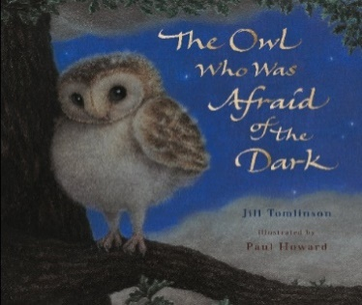 | 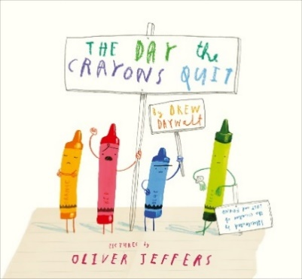 |  | 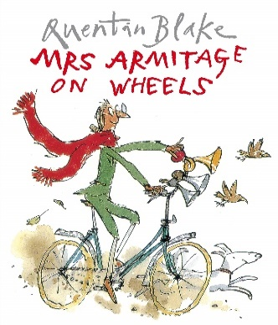
Maths
White Rose Maths – Multiplication & Division  - Recognise equal groups  - Make equal groups  - Add equal groups  - Multiplication sentences using the x symbol  - Multiplication sentences from pictures  - Use arrays  - Make doubles  - 2 times-table  - 5 times-table  - 10 times-table  - Make equal groups - sharing  - Make equal groups - sharing |  | - Make equal groups - grouping  - Make equal groups - grouping  - Divide by 2  - Odd and even numbers  - Divide by 5  - Divide by 10  White Rose Maths – Statistics  - Make tally charts  - Draw pictograms (1-1)  - Interpret pictograms (1-1)  - Draw pictograms (2, 5 and 10)  - Interpret pictograms (2, 5 and 10)  - Block diagrams
Science
Hamilton Trust – Squash, Bend, Twist, Stretch
- Find out how shapes of solid objects made from some materials can be changed by squashing, bending, twisting and stretching.
Geography/History
Key Stage History – The Wright Brothers  - Pupils should be taught about events beyond living memory that are significant nationally or globally [for example, the Great Fire of London, the first aeroplane flight or events commemorated through festivals or anniversaries]  - Pupils should be taught about significant historical events, people and places in their own locality. |  | Key Questions:  - What do you think the Wright brothers did to make them famous? KQ1  - How did the Wright brothers manage to be the first to launch a man powered flight? KQ2  - Why did the Wright brothers succeed where others had failed? KQ3  - The Wright Brothers first flight. KS1 Prove it! task KQ4  - How did flight change as a result of the Wright Brothers’ work? KQ5  - How should the Wright brothers be remembered? Smart task KQ6
Computing
Teach Computing.org – Creating media – Making music  - How music makes us feel  - Rhythms and patterns  - How music can be used |  | - Notes and tempo  - Creating digital music  - Reviewing and editing music
RE
Christianity – Why is ‘Church’ important to Christians?
- Pupils should learn that Christians meet together in a church
- Pupils should learn that the church is not just a building but also a family of Christian people
- Pupils should learn that Christians show God is important to them through worship
- Pupils should learn that there are special Christian symbols in a church building
- Pupils should learn about the main features of a church (interior / exterior)
PSHE
PSHE – Belonging to a Community
- Pupils learn about being a part of different groups, and the role they play in these groups e.g. class, teams, faith groups
- Pupils learn about different rights and responsibilities that they have in school and the wider community
- Pupils learn about how a community can help people from different groups to feel included
- Pupils learn to recognise that they are all equal, and ways in which they are the same and different to others in their community
PSHE – Media Literacy and Digital Resilience
- Pupils learn the ways in which people can access the internet e.g. phones, tablets, computers
- Pupils learn to recognise the purpose and value of the internet in everyday life
- Pupils learn to recognise that some content on the internet is factual and some is for entertainment e.g. news, games, videos
- Pupils learn that information online might not always be true
PE
- Gymnastics |  | - Badminton
Art/DT
Projects on a Page – Mechanisms – Wheels and axles
Designing
- Generate initial ideas and simple design criteria through talking and using own experiences.
- Develop and communicate ideas through drawings and mock-ups.
Making
- Select from and use a range of tools and equipment to perform practical tasks such as cutting and joining to allow movement and finishing.
- Select from and use a range of materials and components such as paper, card, plastic and wood according to their characteristics.
Evaluating
- Explore and evaluate a range of products with wheels and axles.
- Evaluate their ideas throughout and their products against original criteria.
Technical knowledge and understanding
- Explore and use wheels, axles and axle holders.
- Distinguish between fixed and freely moving axles.
- Know and use technical vocabulary relevant to the project.
Music
Charanga – Zootime  Playing  - Learn to play a tuned instrumental part that matches their musical  - challenge, using one of the differentiated parts (a one-note, simple or medium part). |  | - Play the part in time with the steady pulse.  - Listen to and follow musical instructions from a leader.  Composition  - Help create three simple melodies with the Units using one, three or five different notes.  - Learn how the notes of the composition can be written down and changed if necessary.
Resilience, Respect, Aspiration and Trust
During DT this half term, children will aspire to create a vehicle with axles and moving wheels. They will show respect to their peers by giving constructive feedback and praise about each other’s creations. They will have to be resilient when making their creations if it doesn’t go quite right to begin with.

Year 2 Spring 2 – What will we see on our journey around the world?
English
The Write Stuff
- Fiction (Legend) – George and the Dragon
- Non-Fiction (Non-Chronological Report) – Big Cats
Key Texts
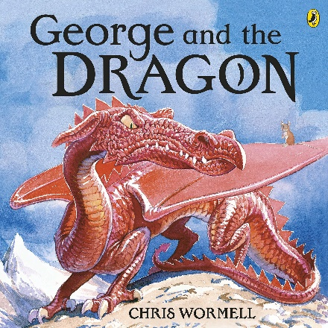 | 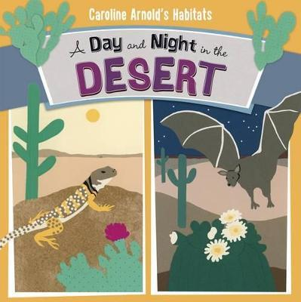 |  | 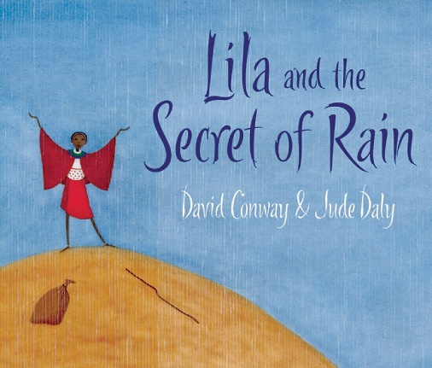
Maths
White Rose Maths – Shape  - Recognise 2-D and 3-D shapes  - Count sides on 2-D shapes  - Count vertices on 2-D shapes  - Draw 2-D shapes  - Lines of symmetry  - Lines of symmetry - draw the whole  - Sort 2-D shapes  - Make patterns with 2-D shapes  - Count faces on 3-D shapes  - Count edges on 3-D shapes  - Count vertices on 3-D shapes  - Sort 3-D shapes  - Make patterns with 3-D shapes |  | White Rose Maths – Fractions  - Make equal parts  - Recognise a half  - Find a half  - Recognise a quarter  - Find a quarter  - Recognise a third  - Find a third  - Unit fractions  - Non-unit fractions  - Equivalence of a half and 2 quarters  - Find three quarters  - Count in fractions  - Problem solving with fractions
Science
Hamilton Trust – Gardens and Allotments
- Describe how animals obtain their food from plants and other animals, using the idea of a simple food chain, and identify and name different sources of food
Geography/History
Voyagers Geography – What will we see on our journey around the world?  - Name and locate the world’s seven continents and five oceans  - Learn about the human and physical geography of a small area in (several) non-European countries  - Read images, maps, atlases and globes  - Ask and answer questions  - Use basic geographical vocabulary. |  | Key Questions:  - What is it like where we live?  - What is it like living by the sea?  - What is it like to live in a rainforest?  - What is it like to live in a dry place?  - What is life like in large cities?
Computing
Teach Computing.org – Data and information – Pictograms
- Counting and comparing
- Enter the data
- Creating pictograms
- What is an attribute?
- Comparing people
- Presenting information
RE
Christianity – Why do Christians call Jesus ‘Saviour’?
- Pupils should learn that friendship is an important value
- Pupils should learn the Bible contains stories about people Jesus met and ‘rescued’
- Pupils should learn that many people’s lives were changed by meeting Jesus
- Pupils should learn that Christians call Jesus ‘Saviour’
Christianity – Why is Easter important to Christians?
- Pupils should learn that friendship is a precious thing and can get damaged
- Pupils should learn that Christians believe that:
- Pupils should learn God loves all people and wants to be their friend
- Pupils should learn the things they do wrong damage their friendship with God
- Pupils should learn Jesus’ death means they can put things right with God again (be forgiven)
- Pupils should learn Jesus’ resurrection means that death is not the end
PSHE
PSHE – Money and Work
- Pupils learn about what money is and its different forms e.g. coins, notes, and ways of paying for things e.g. debit cards, electronic payments
- Pupils learn how money can be kept and looked after
- Pupils learn about getting, keeping and spending money
- Pupils learn that people are paid money for the job they do
- Pupils learn how to recognise the difference between needs and wants
- Pupils learn how people make choices about spending money, including thinking about needs and wants
PE
- Tennis
- Swimming
Art/DT
Digital Media – African landscape
- Use a simple graphics package to create an image with effects using different brush sizes, eraser, shape & fill, simple filters & cropping tool
Music
Charanga – Hands, Feet, Heart
Improvisation
- Listen and clap back, then listen and clap your own answer (rhythms of words).
- Use voices and instruments, listen and sing back, then listen and play your own answer using one or two notes.
- Take it in turns to improvise using one or two notes.
Listen and Appraise
- Learn how they can enjoy moving to music by dancing, marching, being animals or pop stars.
- Learn how songs can tell a story or describe an idea.
Resilience, Respect, Aspiration and Trust
In PSHE, children will think about aspirational jobs they could have when they grow up. They will also learn to respect the lifestyles of others who live in other countries and climates around the world.

Year 2 Summer 1 – Healthy Me
English
The Write Stuff
- Poetry (Humurous Poem) – Desk Diddler
- Non Fiction (Instruction) – How to Make a Bird Feeder
Key Texts
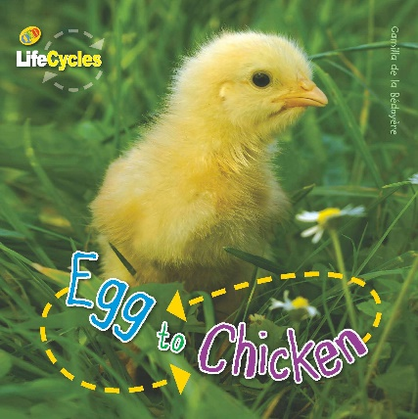 | 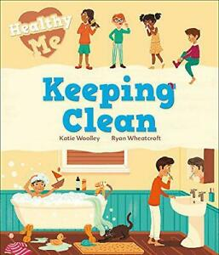 |  | 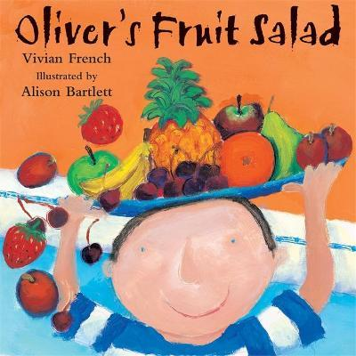
Maths
White Rose Maths – Length and Height  - Compare lengths and heights  - Measure lengths (1)  - Measure lengths (2)  - Measure length (cm)  - Measure length (m)  - Compare lengths  - Order lengths  - Four operations with lengths  - Problem solving with lengths |  | White Rose Maths – Position and Direction  - Describe position (1)  - Describe position (2)  - Problem solving with position  - Describing movement  - Describing turns  - Describing movement and turns  - Describing movement and turns  - Making patterns with shapes
Science
Hamilton Trust – Healthy Animals
- Notice that animals, including humans, have offspring which grow into adults
- Find out about and describe the basic needs of animals, including humans, for survival (water, food and air)
- Describe the importance for humans of exercise, eating the right amounts of different types of food, and hygiene
Hatch and care for chicks
Computing
Teach Computing.org – Programming A – Robot algorithms  - Giving instructions  - Same but different  - Making predictions |  | - Mats and routes  - Algorithm design  - Debugging
RE
Islam – Is prayer important to everyone?
- Pupils should learn that prayer is a way of connecting with God
- Pupils should learn that people pray for different reasons, and that some people don’t pray
- Pupils should learn that people from different religions pray in different ways
- Pupils should learn that non-religious people such as humanists do not believe in a god and so don’t pray
- Pupils should learn that non-religious people might reflect quietly rather than pray
Islam – Who is Allah, and how do Muslims worship him?
- Pupils should learn that Muslims believe in one God, Allah
- Pupils should learn that Allah:
  - is the Arabic name for God the Creator
  - has ninety-nine beautiful names that reflect aspects of his character
- Pupils should learn that Muslims believe that:
  - any thought or action can be a prayer
  - they should be ritually clean** before they pray and can pray anywhere as long as it is clean
  - they should face Makkah when they pray
  - different physical positions in prayer help them focus on Allah
PSHE
PSHE – Physical Health and Mental Wellbeing
- about routines and habits for maintaining good physical and mental health
- why sleep and rest are important for growing and keeping healthy
- that medicines, including vaccinations and immunisations, can help people stay healthy and manage allergies
- the importance of, and routines for, brushing teeth and visiting the dentist
- about food and drink that affect dental health how to describe and share a range of feelings
- ways to feel good, calm down or change their mood e.g. playing outside, listening to music, spending time with others
- how to manage big feelings including those associated with change, loss and bereavement
- when and how to ask for help, and how to help others, with their feelings
PE
- Athletics
- Orienteering
Art/DT
Exploring and Developing Ideas - Magritte
- Record & explore ideas from first-hand observation
- Ask and answer questions about the starting point of their work
- Develop their ideas – try things out, change their minds
- Explore the work of artists, craftspeople and designers from different times and cultures for differences and similarities
Painting: Magritte style painting – The False Mirror
Music
Charanga – Friendship Song
Playing
- Treat instruments carefully and with respect.
- Learn to play a tuned instrumental part that matches their musical challenge, using one of the differentiated parts (a one-note, simple or medium part).
- Play the part in time with the steady pulse.
- Listen to and follow musical instructions from a leader
Singing
- Learn about voices singing notes of different pitches (high and low).
- Learn that they can make different types of sounds with their voices – you can rap (spoken word with rhythm).
- Learn to find a comfortable singing position.
- Learn to start and stop singing when following a leader.
Resilience, Respect, Aspiration and Trust
Children will begin to explore the religion of Islam and will have to show respect towards their views and beliefs. They will begin to understand why prayer is important, and how different religions use prayer to show respect. Children will aspire to create a painting in the style of Magritte and will have to show resilience to keep trying if they don’t get it quite right to begin with.

Year 2 Summer 2 – Let’s Get Growing
English
The Write Stuff
- Non-Fiction (Information Report) – Plant
- Narrative (Story) - The Marvelous Fluffy Squishy Itty Bitty
Key Texts
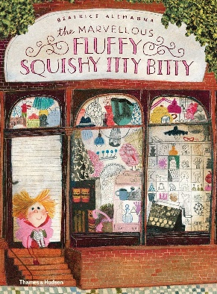 | 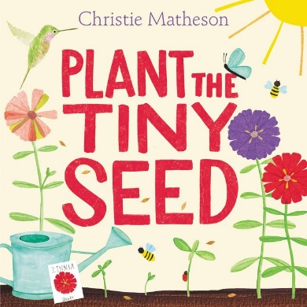
Maths
White Rose Maths – Time  - Telling time to the hour  - Telling time to the half hour  - O'clock and half past  - Quarter past and quarter to  - Telling time to 5 minutes  - Writing time  - Hours and days  - Find durations of time  - Compare durations of time |  | White Rose Maths – Mass, Capicity and Temperature  - Introduce weight and mass  - Measure mass  - Compare mass  - Measure mass in grams  - Measure mass in kilograms  - Introduce capacity and volume  - Measure capacity  - Compare volume  - Millilitres  - Litres  - Four operations with mass  - Four operations with volume  - Temperature
Science
Hamilton Trust – Ready, Steady, Grow!
- Observe and describe how seeds and bulbs grow into mature plants
- Find out and describe how plants need water, light and a suitable temperature to grow and stay healthy
Plan and prepare a healthy snack using fruit and veg (Fruit Kebabs)
Geography/History
Voyagers Geography – Where Does Our Food Come From?  - Understand geographical similarities and differences through studying the human geography of their local shops, and physical geography through studying nearby food growing or production  - Use locational and directional language (e.g. near and far) to describe the location of features and routes on a map  - Name, locate and identify characteristics of the four countries and capital cities of the United Kingdom, and its surrounding seas  - Use world maps, atlases and globes to identify the United Kingdom and its countries, as well as the countries, continents and oceans studied at this key stage. |  | Key Questions:  - What can we buy on our high street?  - How does our food get to the shops?  - What plants does Old Macdonald grow on his farm?  - What animals does Old Macdonald rear on his farm?  - Can we create a Great British picnic?  - Can we create a Great British food map?
Computing
Teach Computing.org – Programming B – An introduction to quizzes  - ScratchJr recap  - Outcomes  - Using a design |  | - Changing a design  - Designing and creating a program  - Evaluating
RE
Islam
- Pupils should learn that the word ‘Islam’ means ‘submission’ in Arabic
- Pupils should learn that ‘respect’ is important to Muslims
- Pupils should learn that Muslims believe that Muhammad (pbuh*):
  - is a prophet and the last messenger of Allah in Islam
  - is the best example of a Muslim, and that they should try to be like him
- Pupils should learn that the Qur’an:
  - is the special book for Muslims and is written in Arabic
  - contains the holy words of Allah to Muhammad
PSHE
PSHE – Growing and Changing  - Pupils learn about the human life cycle and how people grow from young to old  - Pupils learn how our needs and bodies change as we grow up  - Pupils learn to identify and name the main parts of the body including external genitalia (e.g. vulva, vagina, penis, testicles)  - Pupils learn about change as people grow up, including new opportunities and responsibilities  - Pupils learn preparing to move to a new class and setting goals for next year  PSHE – Keeping Safe  - Pupils learn how to recognise risk in everyday situations, e.g. road, water and rail safety, medicines |  | - Pupils learn how to help keep themselves safe in familiar and unfamiliar environments, such as in school, online and ‘out and about’  - Pupils learn to identify potential unsafe situations, who is responsible for keeping them safe in these situations, and steps they can take to avoid or remove themselves from danger  - Pupils learn how to help keep themselves safe at home in relation to electrical appliances, fire safety and medicines/household products  - Pupils learn about things that people can put into their body or onto their skin (e.g. medicines and creams) and how these can affect how people feel how to respond if there is an accident and someone is hurt  - Pupils learn about whose job it is to keep us safe and how to get help in an emergency, including how to dial 999 and what to say
PE
- Rounders
- Handball
Art/DT
Projects on a Page – Mechanisms – Sliders and Levers  Designing  - Generate ideas based on simple design criteria and their own experiences, explaining what they could make.  - Develop, model and communicate their ideas through drawings and mock-ups with card and paper.  Making  - Plan by suggesting what to do next.  - Select and use tools, explaining their choices, to cut, shape and join paper and card.  - Use simple finishing techniques suitable for the product they are creating. |  | Evaluating  - Explore a range of existing books and everyday products that use simple sliders and levers.  - Evaluate their product by discussing how well it works in relation to the purpose and the user and whether it meets design criteria.  Technical knowledge and understanding  - Explore and use sliders and levers.  - Understand that different mechanisms produce different types of movement.  - Know and use technical vocabulary relevant to the project.
Music
Charanga – Reflect, Rewind and Replay
Performance
- Choose a song they have learnt from the Scheme and perform it.
- They can add their ideas to the performance.
- Record the performance and say how they were feeling about it.
Resilience, Respect, Aspiration and Trust
Children will show respect to their peers when playing team sports, such as rounders and handball. They will also need to show respect to the instruments they use in music lessons and treat them with care. They will be aspirational when learning and performing their musical compositions to their peers and will need to show respect when listening to and appraising others’ work.

