Year R Autumn 1 – Knock Knock!
Guiding principles: Unique child, Positive Relationships, Enabling Environments and Learning and Development
We will use the Induction sessions to discover as much as possible about each child by sharing their individual treasure boxes. Our chosen books about being unique will encourage the children to become more confident and self-assured. We introduce the children to the classroom and outdoor environment to encourage them to select their own resources to become independent learners. We will gather information about children’s current levels of development through play-based tasks and computer-based assessments. We will analyse this information to help us prepare future learning experiences.
Characteristics of Effective Learning
- Induction sessions – Getting to know you, understanding rules and routines in school
- Introduce ‘Have a go Writing books, Proud wall (mark making) and Recognition wall (following rules and routines)
Through free flow activities the children will develop the following skills
Playing and Exploring; Realise that their actions have an effect on the world, so they want to keep repeating them; Plan and think ahead about how they will explore or play with objects; Guide their own thinking and actions by referring to visual aids or by talking to themselves while playing; Make independent choices; Basing their own interests and fascinations into early years settings helping them to develop learning; Respond to new experiences. Active learning; Participate in routines; Begin to predict sequences such as routines; Show goal-directed behaviour; Begin to correct mistakes themselves; Keep trying even when things are difficult. Creating and thinking critically; Take part in simple pretend play; Sort materials; Review their progress as they try to achieve a goal; Check how well they are doing; Solve real problems; Use pretend play to think beyond the here and now and to understand another perspective; Feel confident about coming up with their own ideas; Make links between ideas; Concentrate on achieving something that is important to them; Increasingly hold their attention and ignore distractions.
Communication and Language
- Develop good listening skills
- Talk about what makes us special
- Develop language skills through Rising Stars vocabulary sessions: instructions, size and animal movements
- Retell the story ‘Rosie’s walk’
Communication and Language: Understand how to listen carefully and why listening is important; Learn new vocabulary; Use new vocabulary through the day; Develop social phrases; Engage in story times; Listen to and talk about stories to build familiarity and understanding; Retell the story, some as exact repetition and some in their own words; Use new vocabulary in different contexts; Listen carefully to rhymes and songs, paying attention to how they sound; Learn rhymes, poems and songs; Engage in non-fiction books
Key Texts
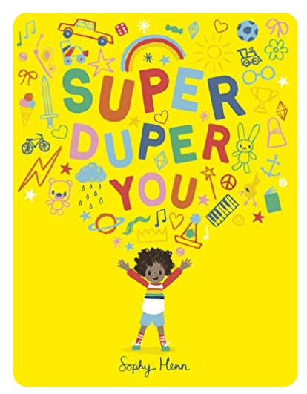 | 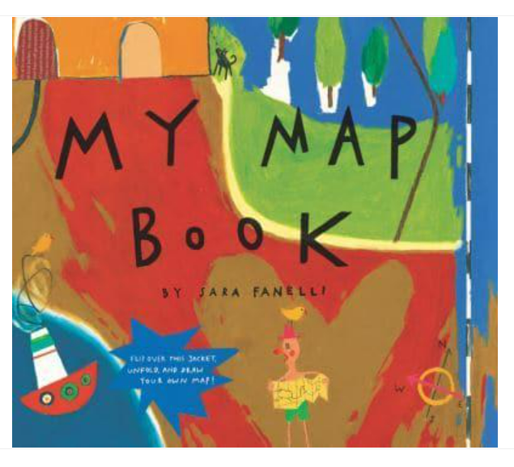 |  | 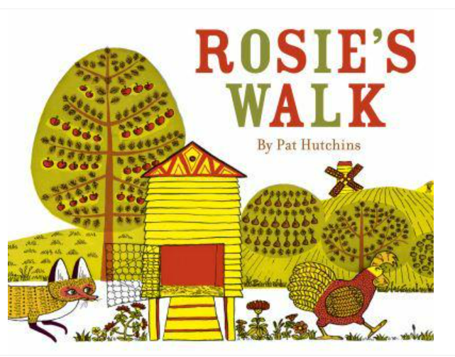
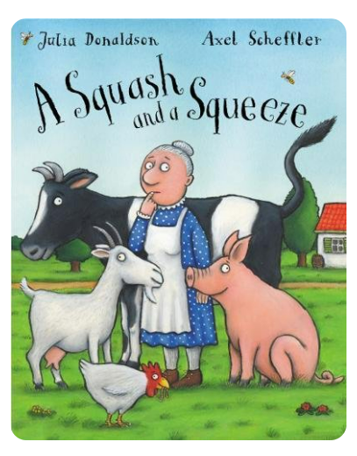 | 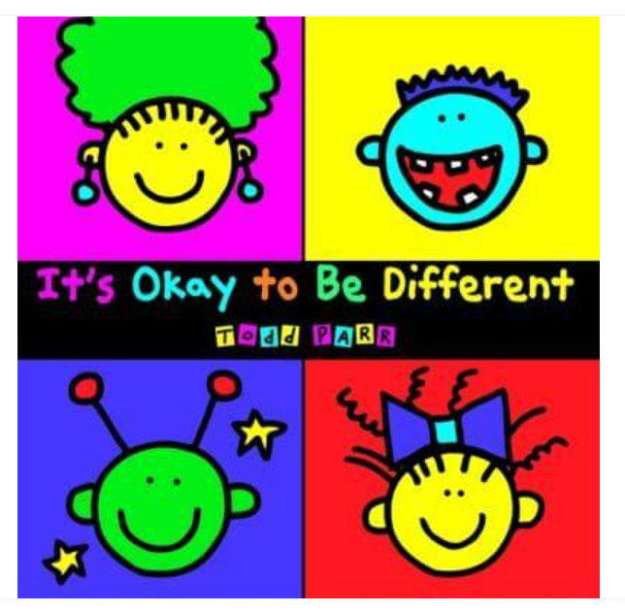 |  | 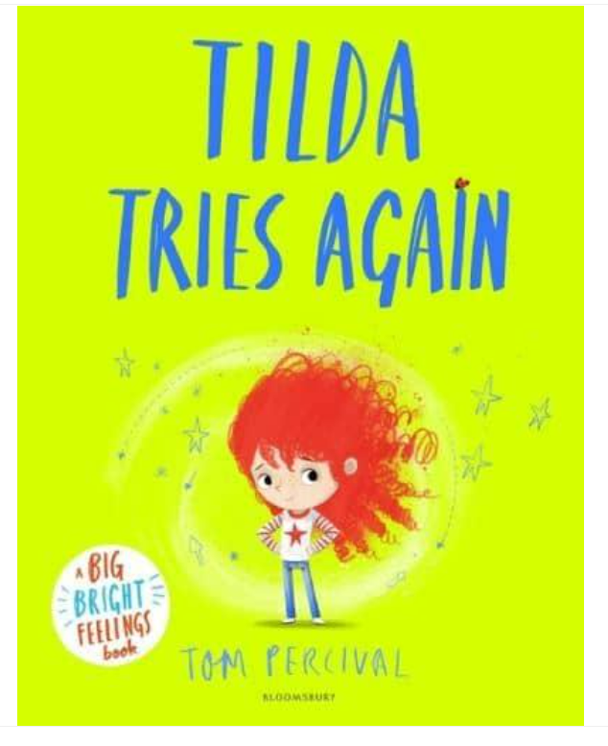
Role Play Area
Home corner
Rosie’s Walk (Farm)
Personal, Social & Emotional Development
- Induction sessions – Getting to know you, understanding rules and routines in school
- Circle time sessions using Family Links Early Years programme; weeks 1-5: Getting to know each other; Making rules and Time out; Praise and Criticism; Personal Power
Personal, Social and Emotional Development: See themselves as valuable individuals; Build constructive and respectful relationships; Express their feelings and consider the feelings of others; Show resilience and perseverance in the face of challenge; Manage their own personal needs.
Physical Development
- Me and myself unit
- Fine motor skills; Dough disco, handwriting patterns and using scissors, knives, forks
- Posture at table in Read, Write, Inc Phonics sessions (RWI)
- School routines

Physical Development: Revise and refine the fundamental movement skills they have already acquired; Progress towards a more fluent style of moving, with developing control and grace; Develop the overall body strength, co-ordination, balance and agility needed to engage successfully engage with physical education sessions; Develop their small motor skills so they can use a range of tools competently, safely and confidently; Use their core muscle strength to achieve a good posture when sitting at a table or sitting on the floor; Combine different movements with ease and fluency; Develop overall body- strength, balance, co-ordination and agility; Develop the foundations of a handwriting style which is fast, accurate and efficient; Further develop the skills they need to manage the school day successfully.
Literacy - Reading
Word Reading  - Sound and listening games  - Introduce Set 1 sounds  - Fred talk – children are given sounds ‘c-a-t’ and asked to say the word ‘cat’  - Red words – Set 1  Literacy: Read individual letters by saying the sounds for them; Blend sounds into words so they can read short words; Read a few common exception words |  | Comprehension  - Listen and respond to stories, poems and songs  - Retell ‘Rosie’s walk’  - Develop language skills through Rising Stars vocabulary sessions  Communication and Language: Learn new vocabulary; Use new vocabulary through the day; Engage in story times; Listen to and talk about stories to build familiarity and understanding; Retell the story, some as exact repetition and some in their own words; Use new vocabulary in different contexts; Listen carefully to rhymes and songs, paying attention to how they sound; Learn rhymes, poems and songs.
Literacy - Writing
- Recognising and writing our names
- Forming letters
Literacy: (3–4-years – Write some or all of their name; Write some letters accurately) / Form lower-case and capital letters correctly.
Mathematics
White Rose – Just like me
Match and Sort
- Same and different Exploring pattern
- Beginning to sort • Making simple patterns; ABAB
Making Comparisons
- Comparing amounts – more/less Fluency fact: 1+1=2
Comparing size, mass and capacity
Mathematics: Count objects, actions and sounds; Compare numbers; Explore the composition of numbers to 10; Automatically recall number bonds for numbers 0-5; Compare length, weight and capacity; Continue, copy and create repeating patterns.
Understanding the World -People, Culture and Communities (Geography & RE)
- RE unit: Who am I? Where do I belong?
- School environment / Buildings we live in
- Simple routes and maps
Understanding the World: Talk about members of their immediate family; Name and describe people who are familiar to them; Draw information from a simple map; Explore the natural world around them; Recognise that some environments are different to the one in which they live.
Technology - Learn to use interactive Whiteboard
Understanding the World – The Natural World (Science)
- Parts of the body
- Keeping healthy
Personal, Social and Emotional Development: Know and talk about the different factors that support overall health and well-being - regular physical activity, healthy eating and toothbrushing.
Expressive Arts and Design - Creating with Materials (Art & DT)
- Self-portraits
- Paint mixing
- Threading activities
- Collage
Expressive Arts and design: Explore, use and refine a variety of artistic effects to express their ideas and feelings; Return to and build on previous learning, refining ideas and developing their ability to represent them.
Expressive Arts and Design – Being Imaginative and Expressive (Music and Drama)
- Me! Charanga music unit
Expressive Arts and design: Listen attentively, move to and talk about music, expressing their feelings and responses; Sing in a group or on their own, increasingly matching the pitch and following the melody; Explore and engage in music making, performing solo or in groups.
Resilience, Respect, Aspiration and Trust
During this unit the children will be introduced to the school values. Adults will use ‘in the moment teaching’ opportunities to demonstrate and explain these values as and when opportunities arise. Children will be introduced to the certificates that are awarded in weekly Achievement assembly for Resilience, Respect, Aspiration and Trust.

Year R Autumn 2 – Let’s Celebrate
Guiding principles: Unique child, Positive Relationships, Enabling Environments and Learning and Development
This unit will deepen relationships within the class through our work in Anti-Bullying week by providing positive examples of how to work and play together collaboratively. We will respond to interests and needs through our work on different celebrations during the unit, where the children will also learn more about different celebrations in our class and school community through planned activities.
Characteristics of Effective Learning
- Continue to develop Have a go Writing books by exploring marking and feedback
- Explore peer-to-peer feedback/learning through ‘Fix it’ time in Maths and RWI sessions
Through free flow activities the children will develop the following skills
Playing and Exploring; Realise that their actions have an effect on the world, so they want to keep repeating them; Plan and think ahead about how they will explore or play with objects; Guide their own thinking and actions by referring to visual aids or by talking to themselves while playing; Make independent choices; Basing their own interests and fascinations into early years settings helping them to develop learning; Respond to new experiences. Active learning; Participate in routines; Begin to predict sequences such as routines; Show goal-directed behaviour; Begin to correct mistakes themselves; Keep trying even when things are difficult. Creating and thinking critically; Take part in simple pretend play; Sort materials; Review their progress as they try to achieve a goal; Check how well they are doing; Solve real problems; Use pretend play to think beyond the here and now and to understand another perspective; Feel confident about coming up with their own ideas; Make links between ideas; Concentrate on achieving something that is important to them; Increasingly hold their attention and ignore distractions.
Communication and Language
- Develop talk partner skills
- Develop language skills through Rising Stars vocabulary sessions: words to describe construction, question words and positional language
- Retell the first Christmas story
Communication and Language: Understand how to listen carefully and why listening is important; Learn new vocabulary; Use new vocabulary through the day; Ask questions to find out more and to check they have understood what has been said to them; Articulate their ideas and thoughts in well-formed sentences; Describe events in some detail; Develop social phrases; Engage in story times; Listen to and talk about stories to build familiarity and understanding; Retell the story, some as exact repetition and some in their own words; Use new vocabulary in different contexts; Listen carefully to rhymes and songs, paying attention to how they sound; Learn rhymes, poems and songs; Engage in non-fiction books.
Key Texts
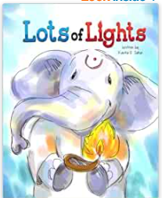 |  | 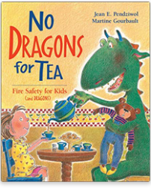 |  |  |  | 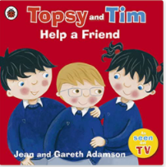
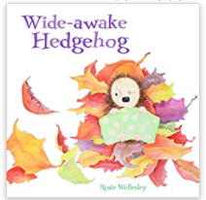 |  | 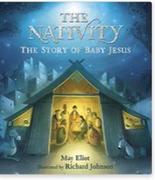 |  |  |  | 
Role Play Area
Home corner |  |  |  |  | Christmas Post Office
Personal, Social & Emotional Development
- Circle time sessions using Family Links EY programme; weeks 6-10: Choices and Consequences; Managing Anger; Gentle touch and Hurting touch; Telling others and keeping secrets; Glad to be me
- Anti-Bullying week
- Fire and Road safety
Personal, Social and Emotional Development: See themselves as valuable individuals; Build constructive and respectful relationships; Express their feelings and consider the feelings of others; Show resilience and perseverance in the face of challenge; Identify and moderate their own feelings socially and emotionally; Think about the perspectives of others; Manage their own needs; Know and talk about the different factors that support their overall health and well-being – having a good sleep routine and being a safe pedestrian.
Physical Development
- Movement and Development unit
- Fine motor skills; Dough disco and handwriting patterns
- Posture at table / carpet (RWI Phonics sessions)
Physical Development: Revise and refine the fundamental movement skills they have already acquired; Progress towards a more fluent style of moving, with developing control and grace; Develop the overall body strength, co-ordination, balance and agility needed to engage successfully engage with physical education sessions; Develop their small motor skills so they can use a range of tools competently, safely and confidently; Use their core muscle strength to achieve a good posture when sitting at a table or sitting on the floor; Further develop and refine a range of ball skills; Develop confidence, competence, precision and accuracy when engaging in activities that involve a ball; Develop the foundations of a handwriting style which is fast, accurate and efficient; Further develop the skills they need to manage a school day successfully.
Literacy - Reading
Word Reading  - Continue to learn Set 1 sounds  - Blend words using known sounds  - Red words – Set 2  Literacy: Read individual letters by saying the sounds for them; Blend sounds into words so they can read short words; Read a few common exception words |  |  |  |  | Comprehension  - Listen and respond to stories, poems and songs  - Retell the first Christmas story  - Develop language skills through Rising Stars vocabulary sessions  Communication and Language: Learn new vocabulary; Use new vocabulary through the day; Engage in story times; Listen to and talk about stories to build familiarity and understanding; Retell the story, some as exact repetition and some in their own words; Use new vocabulary in different contexts; Listen carefully to rhymes and songs, paying attention to how they sound; Learn rhymes, poems and songs.
Literacy - Writing
- Continue to form letters
- Segment sounds to write simple words
- Begin to write labels, lists and cards
Literacy: Form lower-case and capital letters correctly; Spell words by identifying the sounds and then writing the sounds with letter(s); Re-read what they have written to check it makes sense.
Mathematics
White Rose – It’s me 1,2,3  Number  - Representing numbers to 3  - Comparing numbers to 3  - Composition of numbers to 3  Geometry and Spatial thinking  - Circles and triangles  - Positional language and simple routes |  |  |  | White Rose – Light and Dark  Number  - Representing numbers 4 and 5  - One more / less  Geometry and Spatial thinking  - Four sided shapes  Measurement: Time  - Night and Day Fluency facts: 1+1=2 / 2+2=4
Mathematics: Count objects, actions and sounds; Link the number symbol with it cardinal number value; Compare numbers; Understand the one more than /one less than relationship between consecutive numbers; Explore the composition of numbers to 10; Automatically recall number bonds for numbers 0-5; Select, rotate and manipulate shapes to develop spatial reasoning skills; Compose and decompose shapes so that children recognise that shapes can have other shapes within it.
Understanding the World -Past and Present (History)
- Remembrance Day  - Guy Fawkes |  |  | Understanding the World: Comment on images of familiar situations in the past; Compare and contrast characters from stories, including figures from the past.
Understanding the World -People, Culture and Communities (Geography & RE)
- RE unit: Why do we have celebrations?
Understanding the World: Compare and contrast characters from stories, including figures from the past; Talk about members of their immediate family; Name and describe people who are familiar to them; Understand that some places are special to members of their community; Recognise that people have different beliefs and celebrate special times in different ways.
Technology – Introduce Learn Pads
Understanding the World – The Natural World (Science)
- Changes in the seasons – Autumn / Winter
Understanding the World: Explore the natural world around them; Describe what they see, hear and feel whilst outside; Understand the effect of changing seasons on the natural world around them.
Expressive Arts and Design - Creating with Materials (Art & DT)
- Tree and leaf rubbings
- Create collage poppies
- Diwali sand patterns
- Make a Stick man
- Christmas hats
Expressive Arts and design: Explore, use and refine a variety of artistic effects to express their ideas and feelings; Return to and build on previous learning, refining ideas and developing their ability to represent them; Create collaboratively, sharing ideas, resources and skills.
Expressive Arts and Design – Being Imaginative and Expressive (Music and Drama)
- My Stories Charanga music unit
- Learn a part for the class Nativity play and a class song
- Watch Key Stage One Christmas performance
Expressive Arts and design: Listen attentively, move to and talk about music, expressing their feelings and responses; Watch and talk about dance and performance art, expressing their feelings and responses; Sing in a group or on their own, increasingly matching the pitch and following the melody; Explore and engage in music making, performing solo or in groups.
Resilience, Respect, Aspiration and Trust
During this unit the children will explore Respect and Trust through work during Anti-Bullying week and in the exploration of common themes in all celebrations such as food, family and gifts. They will begin to work co-operatively in peer learning opportunities which will also encourage them to aspire to improve their own learning.
 | Year R Spring 1 – Heroes and Helpers
 | Guiding principles: Unique child, Positive Relationships, Enabling Environments and Learning and Development
 | Our unit begins with the idea that we have magic boots that can take us anywhere or do anything. We seek the children’s ideas about where they would like their wellies to take them and use this to plan activities across the term. Our Growth Mindset sessions will encourage a ‘Have a go’ attitude to learning and being independent.
 | Characteristics of Effective Learning
- Growth Mindset sessions: Help I’m stuck, Everyone can learn to ride a bicycle and Incy Wincy Spider
Through free flow activities the children will develop the following skills
.
 | Communication and Language
- Develop language skills through Rising Stars vocabulary sessions: Story language, Describing emotions and Poetry descriptions
- Answering questions – Developing short descriptions
- Class Story telling sessions
Communication and Language: Learn new vocabulary; Use new vocabulary through the day; Ask questions to find out more and to check they have understood what has been said to them; Articulate their ideas and thoughts in well-formed sentences; Connect one idea or action to another using a range of connectives; Describe events in some detail; Engage in story times; Listen to and talk about stories to build familiarity and understanding; Retell the story, some as exact repetition and some in their own words; Use new vocabulary in different contexts; Listen carefully to rhymes and songs, paying attention to how they sound; Engage in non-fiction books; Listen to and talk about selected non-fiction to develop a deep familiarity with new knowledge and vocabulary.
 | Key Texts
 | 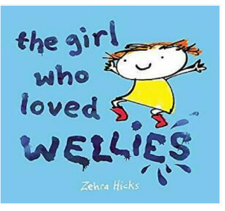 | 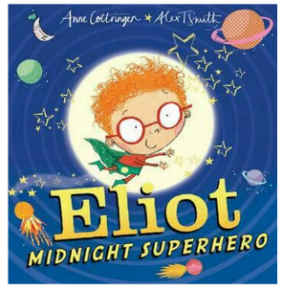 |  |  |  | 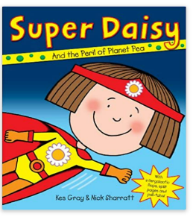
 | 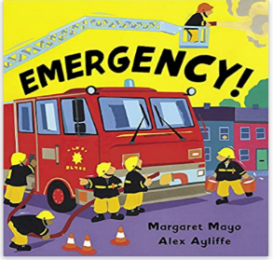 | 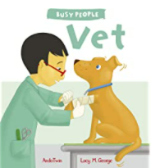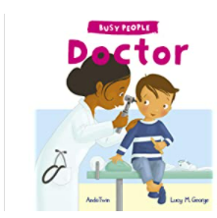
 | Role Play Area
 | Shoe shop |  |  |  | Emergency services role play outside
 | Personal, Social & Emotional Development
- Circle time sessions using Family Links Early Years programme; weeks 1-5: Getting to know each other; Making rules and Time out; Praise and Criticism; Personal Power
- Explore how people help us
Personal, Social and Emotional Development: See themselves as valuable individuals; Build constructive and respectful relationships; Express their feelings and consider the feelings of others; Manage their own personal needs.
 | Physical Development
- Throwing and Catching unit
- Funky fingers fine motor control activities
Physical Development: Revise and refine the fundamental movement skills they have already acquired; Progress towards a more fluent style of moving, with developing control and grace; Develop the overall body strength, co-ordination, balance and agility needed to engage successfully engage with physical education sessions; Develop their small motor skills so that they can use a range of tools competently, safely and confidently; Combine different movements with ease and fluency; Confidently and safely use a range of large and small apparatus indoors and outside, alone and in a group; Develop overall body-strength, balance, co-ordination and agility; Develop the foundations of a handwriting style which is fast, accurate and efficient (RWI sessions)
 | Literacy - Reading
 | Word Reading  - RWI phonics groups  - Read words and begin to read simple sentences  - Red words – Set 3  Literacy: Read individual letters by saying the sounds for them; Blend sounds into words so they can read short words; Read some letter groups that represent one sound and say the sound for them; Read a few common exception words; Read simple phrases and sentences made up of words with known letter-sound correspondences and where necessary a few exception words; Re-read these books to build up their confidence in word reading, their fluency and their understanding and enjoyment. |  |  |  | Comprehension  - Listen and respond to stories, poems and songs  - Develop language skills through Rising Stars vocabulary sessions  Communication and Language: Learn new vocabulary; Use new vocabulary through the day; Engage in story times; Listen to and talk about stories to build familiarity and understanding; Retell the story, some as exact repetition and some in their own words; Use new vocabulary in different contexts; Listen carefully to rhymes and songs, paying attention to how they sound; Learn rhymes, poems and songs.
 | Literacy - Writing
- Ruby’s Worry Write Stuff unit
- Rosie’s Walk Write Stuff unit
- Penguins Non-Fiction (Fact file) Write Stuff unit
Literacy: Form lower-case and capital letters correctly; Spell words by identifying the sounds and then writing the sounds with letter(s); Write short sentences with words with known sound-letter correspondences using a capital letter and full stop; Re-read what they have written to check it makes sense.
 | Mathematics
 | White Rose – Alive in 5!  Number  - Introducing zero  - Representing numbers to 5  - Composition of numbers to 3  - Subitizing  Measurement:  - Comparing mass  - Comparing capacity  Fluency facts: 1+1=2 / 2+2=4 / 3+3=6 / 4+4=8 |  |  | White Rose – Growing 6,7,8  Number  - Representing numbers 6,7, and 8  - Pairs  Calculations  - Combining two groups  Measurement:  - Length and height  - Time (language)
 | Mathematics: Count objects, actions and sounds; Subitize; Link the number symbol with it cardinal number value; Compare numbers; Understand the one more than /one less than relationship between consecutive numbers; Explore the composition of numbers to 10; Automatically recall number bonds for numbers 0-5; Compare length, weight and capacity.
 | Understanding the World -People, Culture and Communities (Geography & RE)
- RE unit: What makes us special?
- Where do different foods come from?
Understanding the World: Talk about members of their immediate family; Name and describe people who are familiar to them; Understand that some places are special to members of their community; Recognise that people have different beliefs and celebrate special times in different ways; Recognise some similarities and differences between life in this country and life in other countries.
Technology – Bee bots and On-line safety
Personal, Social and Emotional Development: Know and talk about different factors that support their overall health and well-being – sensible amounts of screen time.
 | Understanding the World – The Natural World (Science)
 | - Exploring materials |  |  |  | Understanding the World: Explore the natural world around them; Describe what they see, hear and feel whilst outside; Recognise some environments that are different from the one which they live.
 | Expressive Arts and Design - Creating with Materials (Art & DT)
- Jackson Pollock inspired firework pictures for Chinese New Year
- Chinese lanterns and money envelopes
Expressive Arts and design: Explore, use and refine a variety of artistic effects to express their ideas and feelings; Return to and build on previous learning, refining ideas and developing their ability to represent them; Create collaboratively, sharing ideas, resources and skills.
 | Expressive Arts and Design – Being Imaginative and Expressive (Music and Drama)
- Everyone! Charanga music unit
- Class storytelling sessions
Expressive Arts and design: Listen attentively, move to and talk about music, expressing their feelings and responses; Watch and talk about dance and performance art, expressing their feelings and responses; Sing in a group or on their own, increasingly matching the pitch and following the melody; Develop storylines in their pretend play; Explore and engage in music making, performing solo or in groups.
 | Resilience, Respect, Aspiration and Trust
 | During this unit the children will explore Resilience and Aspiration through the Growth Mindset work they complete. Respect and Trust will be developed through circle time sessions and an exploration of Superheroes both imaginary and real-life.

Year R Spring 2 – Fantastic Beasts
Guiding principles: Unique child, Positive Relationships, Enabling Environments and Learning and Development
We will explore self-regulation techniques to develop the children’s independence and to encourage positive relationships with others. Our Growth Mindset sessions will introduce the children to ‘challenge’. We will enhance the learning environment with colour coded challenges to encourage the children to begin to challenge themselves as learners.
Characteristics of Effective Learning
- Growth Mindset sessions: Clever sticks, Toppling towers and Rooting for you (including making and learning from mistakes)
Through free flow activities the children will develop the following skills
Playing and Exploring; Realise that their actions have an effect on the world, so they want to keep repeating them; Plan and think ahead about how they will explore or play with objects; Guide their own thinking and actions by referring to visual aids or by talking to themselves while playing; Make independent choices; Basing their own interests and fascinations into early years settings helping them to develop learning; Respond to new experiences. Active learning; Participate in routines; Begin to predict sequences such as routines; Show goal-directed behaviour; Begin to correct mistakes themselves; Keep trying even when things are difficult. Creating and thinking critically; Take part in simple pretend play; Sort materials; Review their progress as they try to achieve a goal; Check how well they are doing; Solve real problems; Use pretend play to think beyond the here and now and to understand another perspective; Feel confident about coming up with their own ideas; Make links between ideas; Concentrate on achieving something that is important to them; Increasingly hold their attention and ignore distractions.
Communication and Language: Use talk to help work out problems and organise thinking / Personal, Social and Emotional Development: Show resilience and perseverance in the face of challenge.
Communication and Language
- Develop language skills through Rising Stars vocabulary sessions: Story language, Opposites in Nursery rhymes and Measurement words
- Describe and compare ‘Fact’ and ‘Fiction’
- Class Story telling sessions
Communication and Language: Learn new vocabulary; Use new vocabulary through the day; Ask questions to find out more and to check they have understood what has been said to them; Articulate their ideas and thoughts in well-formed sentences; Connect one idea or action to another using a range of connectives; Describe events in some detail; Engage in story times; Listen to and talk about stories to build familiarity and understanding; Retell the story, some as exact repetition and some in their own words; Use new vocabulary in different contexts; Listen carefully to rhymes and songs, paying attention to how they sound; Learn rhymes, poems and songs; Engage in non-fiction books; Listen to and talk about selected non-fiction to develop a deep familiarity with new knowledge and vocabulary.
Key Texts
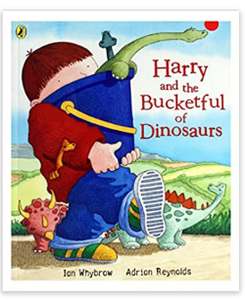 | 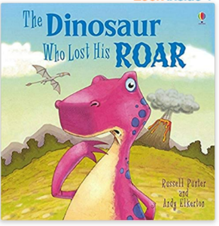 |  |  | 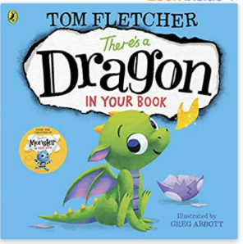
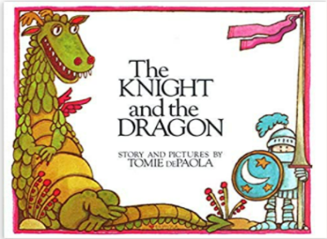 | 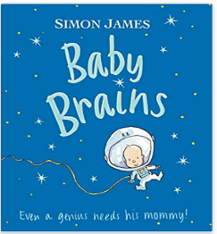 |  |  | 
Role Play Area
Dinosaur museum |  |  | Space station role play outside
Personal, Social & Emotional Development
- Circle time sessions using Family Links Early Years programme; weeks 6-10: Choices and Consequences; Managing Anger; Gentle touch and Hurting touch; Telling others, keeping secrets; Glad to be me
- Demonstrating self-regulation
Personal, Social and Emotional Development: See themselves as valuable individuals; Build constructive and respectful relationships; Express their feelings and consider the feelings of others; Show resilience and perseverance in the face of challenge; Identify and moderate their own feelings socially and emotionally; Think about the perspectives of others.
Physical Development
- Throwing and Catching unit
- Funky fingers fine motor control activities
Physical Development: Revise and refine the fundamental movement skills they have already acquired; Progress towards a more fluent style of moving, with developing control and grace; Develop the overall body strength, co-ordination, balance and agility needed to engage successfully engage with physical education sessions; Develop their fine small motor skills; Combine different movements with ease and fluency; Confidently and safely use a range of large and small apparatus indoors and outside, alone and in a group; Develop overall body-strength, balance, co-ordination and agility; Further develop and refine a range of ball skills; Develop the foundations of a handwriting style which is fast, accurate and efficient (RWI sessions)
Literacy - Reading
Word Reading  - RWI phonics groups  - Begin to read simple sentences independently  - Red words – Set 4  Literacy: Blend sounds into words so they can read short words; Read some letter groups that represent one sound; Read a few common exception words; Read simple phrases and sentences made up of words with known letter-sound correspondences and where necessary a few exception words; Re-read these books to build up their confidence in word reading, their fluency and their understanding and enjoyment. |  |  | Comprehension  - Listen and respond to stories, poems and songs  - Develop language skills through Rising Stars vocabulary sessions  Communication and Language: Learn new vocabulary; Use new vocabulary through the day; Engage in story times; Listen to and talk about stories to build familiarity and understanding; Retell the story, some as exact repetition and some in their own words; Use new vocabulary in different contexts; Listen carefully to rhymes and songs, paying attention to how they sound; Learn rhymes, poems and songs.
Literacy - Writing
- Sam and Dave dig a hole Write Stuff unit
- Jack and the Jellybean stalk Write Stuff unit
- If sharks disappeared Non-Fiction (Report writing) Write Stuff unit
- Literacy: Form lower-case and capital letters correctly; Spell words by identifying the sounds and then writing the sounds with letter(s); Write short sentences with words with known sound-letter correspondences using a capital letter and full stop; Re-read what they have written to check it makes sense.
Mathematics
White Rose – Building 9 and 10  Number  - Representing numbers 9 and 10  - Comparing numbers to 10  - Bonds to 10  Geometry and Spatial thinking:  - 3D shape  Exploring pattern  - Making ABB, AAB, AABB, AABBC and ABC patterns |  | White Rose – Consolidation; ensure good understanding of numbers to 10 before moving onto larger numbers.  Ensure good understanding or pattern and Measurement.  Fluency facts: 1+1=2 / 2+2=4 / 3+3=6 / 4+4=8 / 5+5=10
Mathematics: Count objects, actions and sounds; Subitize; Link the number symbol with it cardinal number value; Compare numbers; Understand the one more than /one less than relationship between consecutive numbers; Explore the composition of numbers to 10; Automatically recall number bonds for numbers 0-5 and some to 10; Compose and decompose shapes so that children recognise a shape can have other shapes within it; Continue, copy and create patterns; Compare length, weight and capacity.
Understanding the World -Past and Present (History)
- Dinosaurs and Archelogy
Understanding the World: Comment on images of familiar situations in the past.
Understanding the World -People, Culture and Communities (Geography & RE)
- RE unit: What makes something special?
Understanding the World: Talk about members of their immediate family; Name and describe people who are familiar to them; Understand that some places are special to members of their community; Recognise that people have different beliefs and celebrate special times in different ways.
Technology – Using simple programs
Understanding the World – The Natural World (Science)
- Dinosaurs and Archelogy
- Changes in the season - Spring time
Understanding the World: Explore the natural world around them; Describe what they see, hear and feel whilst outside; Recognise some environments that are different from the one which they live; Understand the effect of changing seasons on the natural world around them.
Expressive Arts and Design - Creating with Materials (Art & DT)
- Salt dough fossils
- Spaceship junk modelling
- Mother’s Day cards
Expressive Arts and design: Explore, use and refine a variety of artistic effects to express their ideas and feelings; Return to and build on previous learning, refining ideas and developing their ability to represent them; Create collaboratively, sharing ideas, resources and skills.
Expressive Arts and Design – Being Imaginative and Expressive (Music and Drama)
- Our World Charanga music unit
- Class storytelling sessions
Expressive Arts and design: Listen attentively, move to and talk about music, expressing their feelings and responses; Watch and talk about dance and performance art, expressing their feelings and responses; Sing in a group or on their own, increasingly matching the pitch and following the melody; Explore and engage in music making, performing solo or in groups; Develop storylines in their pretend play.
Resilience, Respect, Aspiration and Trust
During this unit the children will explore Resilience and Aspiration through the Growth Mindset work they complete.
Year R Summer 1 – How many legs?
Guiding principles: Unique child, Positive Relationships, Enabling Environments and Learning and Development
Children will be learning the skills needed to work as part of a group or team to complete challenges in their learning; they will continue to develop relationships and have confidence in their own abilities.
Characteristics of Effective Learning
Through free flow activities the children will develop the following skills
Playing and Exploring; Realise that their actions have an effect on the world, so they want to keep repeating them; Plan and think ahead about how they will explore or play with objects; Guide their own thinking and actions by referring to visual aids or by talking to themselves while playing; Make independent choices; Basing their own interests and fascinations into early years settings helping them to develop learning; Respond to new experiences. Active learning; Participate in routines; Begin to predict sequences such as routines; Show goal-directed behaviour; Begin to correct mistakes themselves; Keep trying even when things are difficult. Creating and thinking critically; Take part in simple pretend play; Sort materials; Review their progress as they try to achieve a goal; Check how well they are doing; Solve real problems; Use pretend play to think beyond the here and now and to understand another perspective; Feel confident about coming up with their own ideas; Make links between ideas; Concentrate on achieving something that is important to them; Increasingly hold their attention and ignore distractions.
Communication and Language: Use talk to help work out problems and organise thinking and activities and explain how things work and why they might happen.
Communication and Language
- Re-cap and consolidate language from previous Rising Stars vocabulary sessions as necessary
- Observe, describe and compare minibeasts
- Explore life cycles and changes that occur
- Class Story telling sessions
Communication and Language: Learn new vocabulary; Use new vocabulary through the day; Ask questions to find out more and to check they have understood what has been said to them; Articulate their ideas and thoughts in well-formed sentences; Connect one idea or action to another using a range of connectives; Describe events in some detail; Engage in story times; Listen to and talk about stories to build familiarity and understanding; Retell the story, some as exact repetition and some in their own words; Use new vocabulary in different contexts; Listen carefully to rhymes and songs, paying attention to how they sound; Engage in non-fiction books; Listen to and talk about selected non-fiction to develop a deep familiarity with new knowledge and vocabulary.
Key Texts
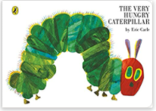 | 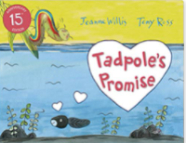 |  |  | 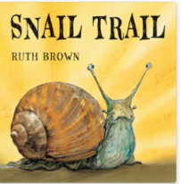
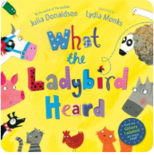 | 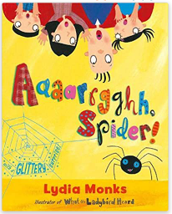 |  |  | 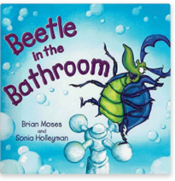
Role Play Area
Minibeast investigation station |  |  | Garden centre role play outside
Personal, Social & Emotional Development
- Circle time sessions using Family Links Early Years programme; weeks 1-5: Getting to know each other; Making rules and Time out; Praise and Criticism; Personal Power
- Relationship and Sex Education sessions (RSE); Caring friendships, Being kind and Families
Personal, Social and Emotional Development: See themselves as valuable individuals; Build constructive and respectful relationships; Express their feelings and consider the feelings of others.
Understanding the World: Talk about members of their immediate family and community; Name and describe people who are familiar to them.
Physical Development
- Fun and Games unit
- Daily Mile introduction – begin to build running stamina
- Funky fingers fine motor control activities
Physical Development: Revise and refine the fundamental movement skills they have already acquired; Progress towards a more fluent style of moving, with developing control and grace; Develop the overall body strength, co-ordination, balance and agility needed to engage successfully engage with physical education sessions; Develop their small motor skills so that they can use a range of tools competently, safely and confidently; Combine different movements with ease and fluency; Confidently and safely use a range of large and small apparatus indoors and outside, alone and in a group; Develop overall body-strength, balance, co-ordination and agility; Develop the foundations of a handwriting style which is fast, accurate and efficient; Further develop the skills they need to manage the school day successfully.
Literacy - Reading
Word Reading  - RWI phonics groups  - Read simple sentences independently  - Red words – Set 5  Literacy: Blend sounds into words so they can read short words; Read some letter groups that represent one sound and say sounds for them; Read a few common exception words; Read simple phrases and sentences made up of words with known letter-sound correspondences and where necessary a few exception words; Re-read these books to build up their confidence in word reading, their fluency and their understanding and enjoyment. |  |  | Comprehension  - Listen and respond to stories, poems and songs  - Develop language skills through Rising Stars vocabulary sessions  Communication and Language: Learn new vocabulary; Use new vocabulary through the day; Engage in story times; Listen to and talk about stories to build familiarity and understanding; Retell the story, some as exact repetition and some in their own words; Use new vocabulary in different contexts; Listen carefully to rhymes and songs, paying attention to how they sound; Learn rhymes, poems and songs.
Literacy - Writing
- Chocolate Mug cake Non-fiction (Instructions) Write Stuff unit
- We’re going on a bear hunt Write Stuff unit
- Where the wild things are Write Stuff unit
Literacy: Form lower-case and capital letters correctly; Spell words by identifying the sounds and then writing the sounds with letter(s); Write short sentences with words with known sound-letter correspondences using a capital letter and full stop; Re-read what they have written to check it makes sense.
Mathematics
White Rose – To 20 and beyond  Number  - Representing numbers to 20 and beyond  - Counting patterns beyond 10  Geometry and Spatial thinking:  - Spatial reasoning  Fluency facts: 1+1=2 / 2+2=4 / 3+3=6 / 4+4=8 / 5+5=10 / 2+1=3 |  | White Rose – First, Then, Now  Number  - Representing numbers to 20 and beyond  - Counting patterns beyond 10  Calculations:  - Adding More  - Taking Away  Geometry and Spatial thinking:  - Spatial reasoning
Mathematics: Count objects, actions and sounds; Subitize; Link the number symbol with it cardinal number value; Count beyond 10; Compare numbers; Understand the one more than /one less than relationship between consecutive numbers; Explore the composition of numbers to 10; Automatically recall number bonds for numbers 0-5 and some to 10; Select, rotate and manipulate shapes to develop spatial reasoning skills.
Understanding the World: Draw information from a simple map.
Understanding the World -Past and Present (History)
Understanding the World -People, Culture and Communities (Geography & RE)
- RE unit: How is the World special?
Understanding the World: Draw information from a simple map; Recognise that people have different beliefs and celebrate special times in different ways; Recognise some similarities and differences between life in this country and life in other countries; Recognise some environments that are different to the one in which they live.
Technology – Taking photos and short videos using the camera function
Understanding the World – The Natural World (Science)
- Observations and descriptions of minibeasts  - Lifecycles of minibeasts |  |  | Understanding the World: Explore the natural world around them; Describe what they see, hear and feel whilst outside; Recognise some environments that are different from the one which they live.
Expressive Arts and Design - Creating with Materials (Art & DT)
- 3D spiders and caterpillars
- Matisse style snails
- Monet style painting
Expressive Arts and design: Explore, use and refine a variety of artistic effects to express their ideas and feelings; Return to and build on previous learning, refining ideas and developing their ability to represent them.
Understanding the World: Comment on images of familiar situations in the past; Compare and contrast characters from stories, including figures from the past.
Expressive Arts and Design – Being Imaginative and Expressive (Music and Drama)
- Big Bear Funk Charanga music unit
- Class storytelling sessions
Expressive Arts and design: Listen attentively, move to and talk about music, expressing their feelings and responses; Watch and talk about dance and performance art, expressing their feelings and responses; Sing in a group or on their own, increasingly matching the pitch and following the melody; Develop storylines in their pretend play; Explore and engage in music making, performing solo or in groups.
Resilience, Respect, Aspiration and Trust
During this unit the children will further develop their own Resilience and Aspiration through learning to work as part of a group. They will explore Respect and Trust through RSE sessions on friendships, being kind and families.
Year R Summer 2 – Happily Ever After
Guiding principles: Unique child, Positive Relationships, Enabling Environments and Learning and Development
We will adapt our planning and environment to ensure children have the skills for learning outlined in ‘Characteristics of Effective Learning’. We will also ensure the children have, where possible, achieved end of year expectations in the Prime areas to enable them to build on their learning in Year 1. We will complete Transition sessions to ensure the children are confident and self-assured going into Year 1.
Characteristics of Effective Learning
Through free flow activities the children will develop the following skills
Playing and Exploring; Realise that their actions have an effect on the world, so they want to keep repeating them; Plan and think ahead about how they will explore or play with objects; Guide their own thinking and actions by referring to visual aids or by talking to themselves while playing; Make independent choices; Basing their own interests and fascinations into early years settings helping them to develop learning; Respond to new experiences. Active learning; Participate in routines; Begin to predict sequences such as routines; Show goal-directed behaviour; Begin to correct mistakes themselves; Keep trying even when things are difficult. Creating and thinking critically; Take part in simple pretend play; Sort materials; Review their progress as they try to achieve a goal; Check how well they are doing; Solve real problems; Use pretend play to think beyond the here and now and to understand another perspective; Feel confident about coming up with their own ideas; Make links between ideas; Concentrate on achieving something that is important to them; Increasingly hold their attention and ignore distractions.
Communication and Language
- Re-cap and consolidate language from previous Rising Stars vocabulary sessions as necessary
- Identify key features of narratives through re-telling Traditional stories
- Develop story telling language during Story telling sessions
Communication and Language: Learn new vocabulary; Use new vocabulary through the day; Ask questions to find out more and to check they have understood what has been said to them; Articulate their ideas and thoughts in well-formed sentences; Connect one idea or action to another using a range of connectives; Describe events in some detail; Engage in story times; Listen to and talk about stories to build familiarity and understanding; Retell the story, some as exact repetition and some in their own words; Use new vocabulary in different contexts.
Key Texts
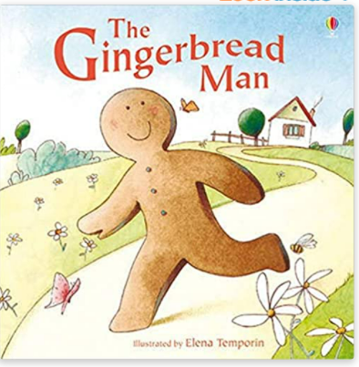 | 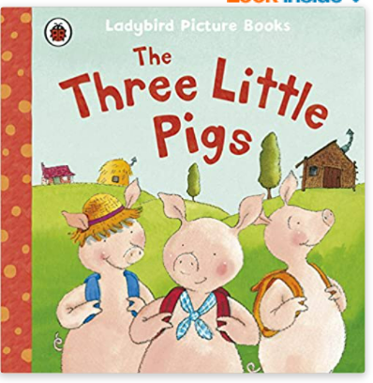 |  |  | 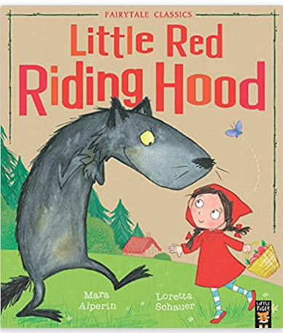
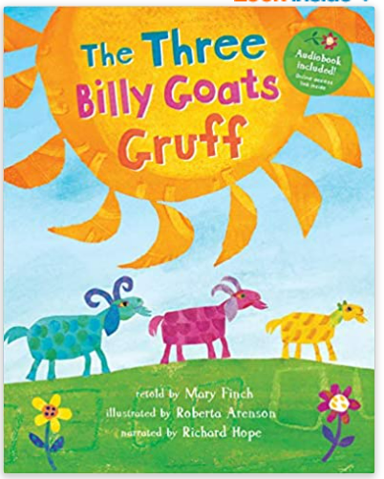 | 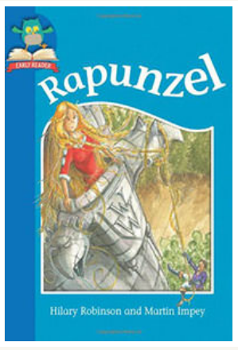 |  |  | 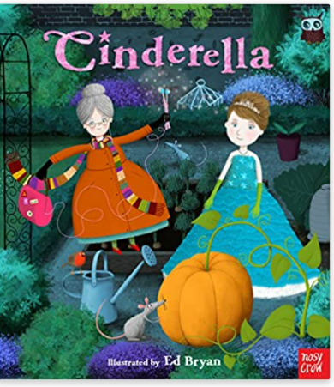
Role Play Area
Bakery |  |  | Castle role play outside
Personal, Social & Emotional Development
- Circle time sessions using Family Links Early Years programme; weeks 6-10: Choices and Consequences; Managing Anger; Gentle touch and Hurting touch; Telling others, keeping secrets; Glad to be me
- Reflecting on our time in Reception
- Preparing for Year 1
Personal, Social and Emotional Development: See themselves as valuable individuals; Build constructive and respectful relationships; Express their feelings and consider the feelings of others; Show resilience and perseverance in the face of challenge; Identify and moderate their own feelings socially and emotionally; Manage their own needs; Think about the perspectives of others; Know and talk about the different factors that support their overall health and well-being.
Physical Development
- Working with others unit
- Sports Day race practice / Daily Mile
- Funky fingers fine motor control activities
Physical Development: Revise and refine the fundamental movement skills they have already acquired; Progress towards a more fluent style of moving, with developing control and grace; Develop the overall body strength, co-ordination, balance and agility needed to engage successfully engage with physical education sessions; Develop their small motor skills so that they can use a range of tools competently, safely and confidently; Combine different movements with ease and fluency; Confidently and safely use a range of large and small apparatus indoors and outside, alone and in a group; Develop overall body-strength, balance, co-ordination and agility; Develop the foundations of a handwriting style which is fast, accurate and efficient; Further develop the skills they need to manage the school day successfully.
Literacy -Reading
Word Reading  - RWI phonics groups  - Read simple sentences independently  - Red words – Set 6  Literacy: Blend sounds into words so they can read short words; Read some letter groups that represent one sound and say sounds for them; Read a few common exception words; Read simple phrases and sentences made up of words with known letter-sound correspondences and where necessary a few exception words; Re-read these books to build up their confidence in word reading, their fluency and their understanding and enjoyment. |  |  | Comprehension  - Listen and respond to stories, poems and songs  - Develop language skills through Rising Stars vocabulary sessions  Communication and Language: Learn new vocabulary; Use new vocabulary through the day; Engage in story times; Listen to and talk about stories to build familiarity and understanding; Retell the story, some as exact repetition and some in their own words; Use new vocabulary in different contexts; Listen carefully to rhymes and songs, paying attention to how they sound; Learn rhymes, poems and songs.
Literacy - Writing
- I wanna Iguana Non-fiction (Persuasion letter) Write Stuff unit
- Handa’s surprise Write Stuff unit
- Perfectly Norman Write Stuff unit
- Rainbow Fish Write Stuff unit
Literacy: Form lower-case and capital letters correctly; Spell words by identifying the sounds and then writing the sounds with letter(s); Write short sentences with words with known sound-letter correspondences using a capital letter and full stop; Re-read what they have written to check it makes sense.
Mathematics
White Rose – Find my pattern  Number  - Consolidate work on numbers to 20  - Odd and Even numbers  Calculations:  - Doubling  - Sharing and grouping  Geometry and Spatial thinking:  - Spatial reasoning |  | White Rose – On the move  Number  - Consolidate work on numbers to 20 and beyond  Exploring pattern  Consolidate work on patterns, including counting patterns  Geometry and Spatial thinking:  - Spatial reasoning  Fluency facts: 1+1=2 / 2+2=4 / 3+3=6 / 4+4=8 / 5+5=10 / 2+1=3 / 2+3=5
Mathematics: Count objects, actions and sounds; Subitize; Link the number symbol with it cardinal number value; Count beyond 10; Compare numbers; Understand the one more than /one less than relationship between consecutive numbers; Explore the composition of numbers to 10; Automatically recall number bonds for numbers 0-5 and some to 10; Select, rotate and manipulate shapes to develop spatial reasoning skills; Compose and decompose shapes; Continue, copy and create repeating patterns.
Understanding the World: Draw information from a simple map.
Understanding the World -People, Culture and Communities (Geography & RE)
- RE unit: What can we learn from stories?
Understanding the World: Comment on images of familiar situations in the past; Compare and contrast characters from stories, including figures from the past; Recognise some similarities and differences between life in this country and life in other countries.
Technology – Taking photos and short videos using the camera function
Understanding the World – The Natural World (Science)
- Working Scientifically – STEM activities, including changing states
- Changes in the season – Summertime
Understanding the World: Explore the natural world around them; Describe what they see, hear and feel whilst outside; Recognise some environments that are different from the one which they live; Understand the effect of changing seasons on the natural world around them.
Communication and Language: Use talk to help them work out problems and organise thinking and activities and to explain how things work and why they might happen.
Expressive Arts and Design - Creating with Materials (Art & DT)
- 3D castles (including explaining their creative processes)
- Make a simple bag for Red Riding hood
- Observational drawings (detail in drawing)
- Father’s Day cards
Expressive Arts and design: Explore, use and refine a variety of artistic effects to express their ideas and feelings; Return to and build on
previous learning, refining ideas and developing their ability to represent them; Create collaboratively, sharing ideas, resources and skills.
Expressive Arts and Design – Being Imaginative and Expressive (Music and Drama)
- Reflect, Rewind, replay Charanga music unit
- Class storytelling sessions
Expressive Arts and design: Listen attentively, move to and talk about music, expressing their feelings and responses; Watch and talk about dance and performance art, expressing their feelings and responses; Sing in a group or on their own, increasingly matching the pitch and following the melody; Explore and engage in music making, performing solo or in groups; Develop storylines in their pretend play.
Resilience, Respect, Aspiration and Trust
During this unit the children will explore the values of Resilience, Respect, Trust and Aspiration through their reflections on the past year and by looking forward to Year 1, including writing a comment for their end of year report.

