**2019/2020 - Year 3 Autumn 1**

**What was life like in the Stone Age?**

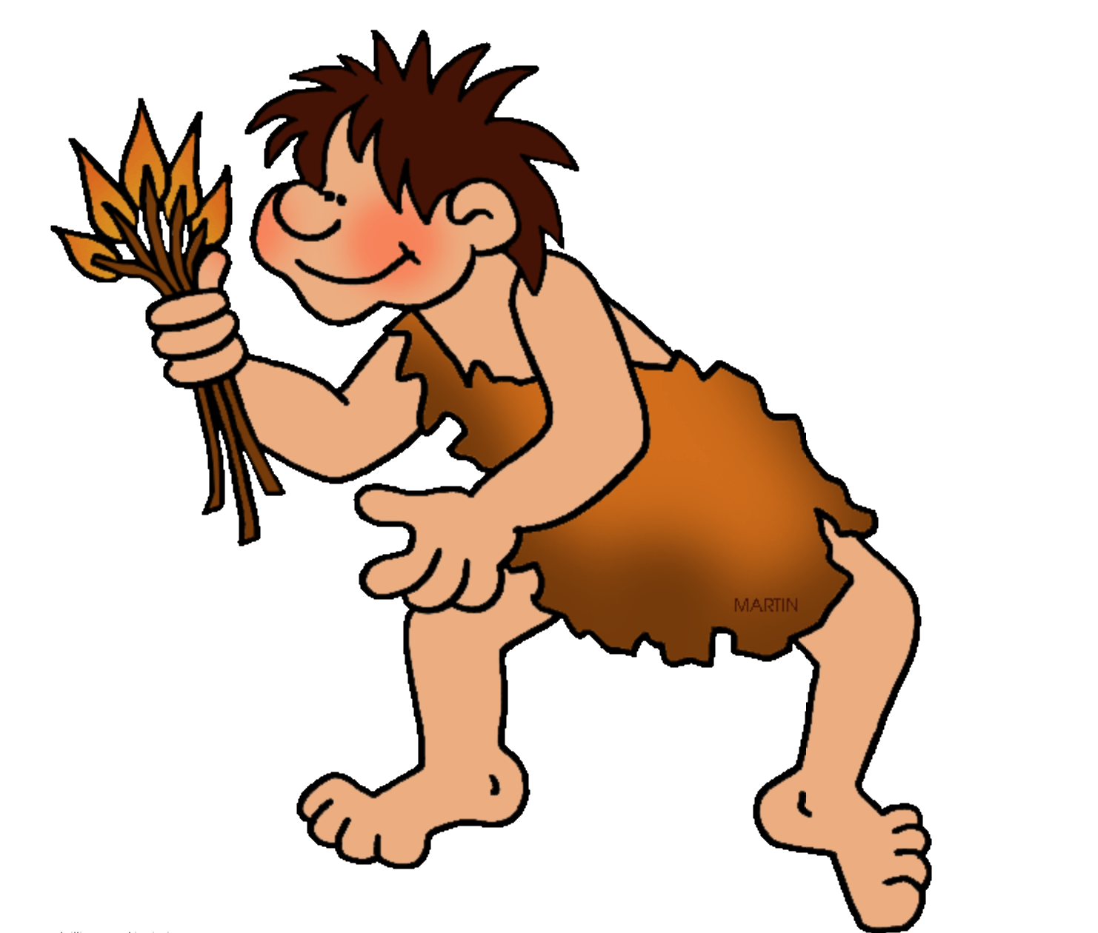

Religious Education

* Investigate how people answer the question: How did it all begin?
* Describe similarities and differences in beliefs about creation.
* Evaluate a range of sources and explain reasons for different viewpoints and beliefs.

English

* How to Trap a Woolly Mammoth – instructions (2 weeks)
* The Stone Age Boy – narrative (3 weeks)
* Non-fiction linked to Science topic (2 weeks)
* SPaG: Adverbial phrases, imperative verbs and conjunctions.
* Spelling: suffixes, prefixes, contractions. Key words from statutory spelling list.

Music

* Listen to and appraise different types of music.
* Play instruments with increasing fluency.
* Improvise to a piece of music.

Languages

* Understand simple instructions in French.
* Speak confidently using greetings and introductions.
* Know how to count to 10 in French.

Computing

* Use technology safely, respectively and responsibly.
* Know how to create and save documents
* Develop word processing skills.

Art/DT

* Evaluate and analyse a range of cave paintings.
* Create sketches to record observations and for reviewing ideas.
* Use a range of materials and techniques to create an authentic cave painting.

PSHE

* Goal to success - determination
* Working with others - collaboration

History

* Describe and understand the key aspects of life in the Stone Age.
* Explore how life in Britain changed during this period of time.
* Examine a range of historical evidence to draw conclusions and develop knowledge about the past.

Spoken Language

* + - * Listen and respond appropriately.
* Select and use appropriate registers for effective communication.
* Ask relevant questions to expand and extend understanding and knowledge.
* Use relevant strategies to build vocabulary.
* Participate in presentations and debates.

Physical Education

* Participate in team games, developing simple tactics for attacking and defending.
* Play competitive games and apply basic principles.

Science

* Identify parts of the body including the skeleton and muscles.
* Classify and compare different types of animal.
* Explain why some animals have skeletons and muscles for support, protection and movement.
* Identify that animals get nutrition from what they eat.
* Research food groups and explain how they keep us healthy.

Mathematics

* Counting: 100s, 50s, 10s, 4s, 8s, 1s
* Place Value: Partition 3d numbers
* Compare and order numbers with up to 3d
* Addition/Subtraction: 3d + 2d/3d – 2d
* Counting on
* Counting back
* Formal Written Method
* Bar Models